`

SCHOOL *of* BUSINESS AND TECHNOLOGY

Department of Engineering and Aviation Sciences

**Design of a Ground Rover with TI mmWave Radar Sensor for Geographical Acquisition in Disaster Rescue Applications**

**Jesudara Omidokun**

**Aduralere Sulaiman**

Advisor: Dr. Lei Zhang

Dec 11, 2019

Design of a Ground Rover with TI mmWave Radar Sensor for Geographical Acquisition in Disaster Rescue Applications

By

Jesudara Omidokun and Aduralere Sulaiman

Submitted to the Department of Engineering and Aviation Sciences in partial fulfillment of the requirements for the degree of Bachelor of Science in Engineering at the

UNIVERSITY OF MARYLAND EASTERN SHORE

Date: Dec 11, 2019

The author hereby grants the University of Maryland Eastern Shore permission to reproduce and distribute publicly, paper and or electronic copies of this document in whole or in parts.

Authors Jesudara Omidokun, Aduralere Sulaiman

Signature

Date Dec 10, 2019

Department of Engineering and Aviation Sciences

Certified by

List of Contents

List of Contents 3

List of Figures 2

List of Tables 3

1. Introduction 4

1.1 Backgound/Motivation 4

1.2 Objective 5

1.3 Design Requirements 5

1.4 Design Constraints 6

1.5 Design Method (Approach) 6

1.6 Standards 6

2. Project Description 6

2.1 System Description 7

2.2 System Diagram 7

2.3 System Functions 7

3. Implementation Plan 9

3.1 Tasks 9

3.2 Team Organization 10

3.2.1. Responsibility of Team member 1 10

3.2.2. Responsibility of Team member 2 10

3.3 Timeline/Milestones/Delivery Plan 10

4. Implementation 12

4.1 Implementation of Task 1. 12

4.1.1. Implementation of Subtask 1.1 12

4.1.2. Implementation of Subtask 1.2 19

4.1.3. Implementation of Subtask 1.3 20

4.2 Implementation of Task 2. 21

4.2.1. Implementation of Task 2 Subtask 1 21

4.2.2. Implementation of Task 2 Subtask2 22

4.2.3. Implementation of Task 2 subtask 3 23

4.3 Implementation of Task 3 23

4.3.1. Implementation of Task 3 Subtask 1 23

4.3.2. Implementation of Task 3 Subtask 2 23

4.4 Implementation of Task 4 23

4.4.1. Implementation of Task 4 subtask 1 24

4.4.2. Implementation of Task 4, Subtask 2 25

4.4.3. Implementation of Task 4, Subtask 3 28

4.5 Implementation of Task 5 30

4.6 Implementation of Task 6 32

4.7 Implementation of Task 7 34

4.8 Implementation of Task 8. 36

4.9 Implementation of Task 9 37

Appendix 40

A. Source Code. 40

1. Source Code of Line Sensor 40

2. Source Code of Bump Switches 40

3. Source Code of 4k FFT Stiching Algorithm 41

4. Source Code of .Obj to .Pcd Converter 56

5. Source Code for ROS Installation 56

REFERENCES 58

List of Figures

Fig. 1 A Robot Used to Diffuse a Bomb 6

Fig. 2 A Hornet Drone Used for Engaging Targets 6

Fig. 3 Momaro Robot Used in Disaster Rescue 6

Fig. 4 System Diagram. 8

Fig. 5 Componets Used in Assembling the RSLK 13

Fig. 6 Tools Used in Assembling the RSLK 14

Fig. 7 Assembled TI RSLK 14

Fig. 8 Battery Connections Soldered as Part of the Attachment to the Chassis 15

Fig. 9 LaunchPad Soldered Together with Long pins Facing Upward. 16

Fig. 10 Encoders Soldered to Motor Drivers. 16

Fig. 11 Bump Switches 17

Fig. 12 Motor Board on Chassis 17

Fig. 13 Ball Caster 18

Fig. 14 Wheels of the Car 18

Fig. 15 Bump Switches Wiring 19

Fig. 16 Motor Board Wiring to LaunchPad 19

Fig. 17 Line Sensor Wiring Guide 20

Fig. 18 Error Message Received 21

Fig. 19 Switching off the Antivirus 21

Fig. 20 Assembled TI RSLK 22

Fig. 21 Flow Chart for Line Sensor 23

Fig. 22 5V Power Supply 24

Fig. 23 Schematics of Buck Converter 24

Fig. 24 Front view of the IWR1443 25

Fig. 25 Back view of the IWR 1443 25

Fig. 26 Block diagram of the IWR1443 25

Fig. 27 Solution to the 27

Fig. 28 3D Stitching of Point Cloud Data 28

Fig. 29 Prebuilt in Binaries 29

Fig. 30 COMuart Entry 29

List of Tables

Table 1. Task Assignment for Spring 2019 11

Table 2. Task Assignment for Fall 2019 12

Table 3. Components of the Ti Rslk 14

Table 4. Bump Switches Connection Guide 19

Table 5. Motorboard Wiring Guide 19

Table 6. Motorboard Wiring From Ground And Vreg 19

Table 7. Line Sensor Wiring Guide 20

1. Introduction

In this project, an autonomous rover is to be developed implementing the mmWave sensor (IWR1443BOOST). The autonomous rover will be capable of different functions such as providing geographical information (such as range, velocity, and angle) and proximity & position sensing.

## Backgound/Motivation

The TI Robotics Systems Learning Kit was created by TI as a low-cost robotics kit to provide students with a profound understanding of how electronic devices work. It was developed in conjunction with Dr. Jon Valvano, professor, electrical and computer engineering at The University of Texas at Austin. There are two different RSLK kits; the basic kit which teaches the foundations of an electric system and the advanced kit which contains all components found in the basic kit, adding wireless communication to enable the robot to solve its way through a maze by detecting lines and obstacles.

The mmWave sensor is an extremely valuable sensing technology for the detection of objects and providing the range, velocity, and angle of these objects. It is a contactless technology that operates in the spectrum between 30GHz and 300GHz. Due to the technology’s use of small wavelengths, it can provide sub-mm range accuracy and is able to penetrate certain materials such as plastic, drywall, clothing, and is impervious to environmental conditions such as rain, fog, dust, and snow. The mmWave sensor has a clear advantage over other sensing technologies such as ultrasonic sensors and LIDAR. It has a long detection range, narrow and wide detection angle, good range resolution, and has good night operation performance.

The rover can be used in many situations such as in disaster rescuing. In such situations, instead of law enforcement agencies to go in with guns blazing, it is better to access the situation at hand. Many products are on the market, some of which map and maneuver disaster areas after calamities have taken place, assist firefighters, and many more. The mmWave sensor on the rover can provide 3D point cloud information on the building where the situation occurred. It will also work better than a camera because of its long detection range, it’s narrow and wide detection angle, as well as it is good range resolution. From the 3D point cloud information provided by the mmWave sensor, the rover would be able to provide the best possible route for the officers to avoid obstacles.

The rover can be used in disaster rescue applications where it will be difficult for just humans to perform rescue operations. In March 2011, a powerful earthquake triggered a tsunami that destroyed the Fukushima-Daiichi nuclear plant which resulted in alarming levels of radiation. Authorities contemplated ending robots first to access the situation but eventually, the robots could not live up to the task and humans had to complete most of the hazardous work.

Ever since then, government agencies have been working to improve the quality of robots. There are even global competitions to design robots that can perform rescue work. The purpose of this project is to develop a system that would help with rescuing disasters that share the functionalities of robots that help in rescuing.

Fig 1a and 1b. show different robots that are used by the government.

Fig 1c is the Momaro robot that has been specifically designed by the team NimbRo Rescue from the University of Bonn in Germany.which can accomplish similar tasks as our devices. However, from a financial standpoint, this costs more than our device.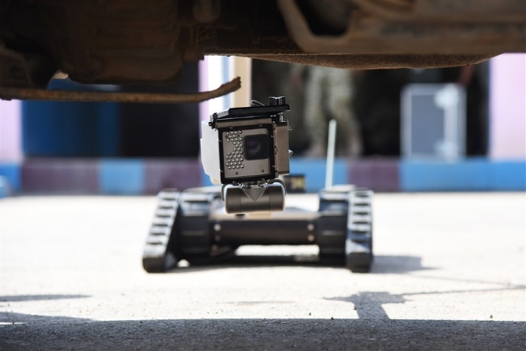 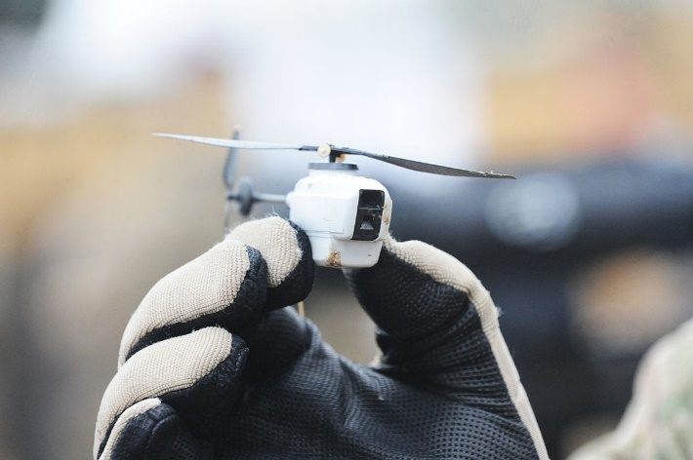

Fig. 1a A Robot Used to Defuse a Bomb Fig. 1b A Hornet Drone Used for Engaging Targets

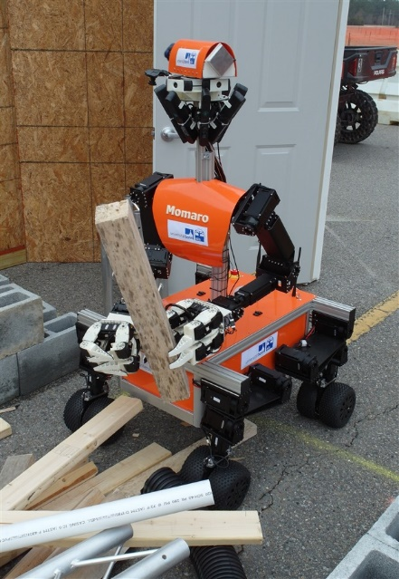

Fig. 1c Momaro Robot Used in Disaster Rescue

## Objective

The objective of the project is to design a rover that can acquire geographical information such as the range, velocity, angle and 3D imaging of objects in an unknown area.

## Design Requirements

1. The device will be able to visualize data (provide point cloud information).
2. The device will be able to avoid obstacles while providing autonomous navigation
3. The payload of the car will be 15 to 20lbs
4. The device will detect an object within the range of 3cm to 10 m.
5. The device will have a resolution range of 10cm

## Design Constraints

1. The rover might not be able to move well in certain terrains such as rocky areas because of its wheels.
2. Battery will have to be recharged after about 4 hours of use
3. The device would only work in mild weather conditions.
4. Budget of $600

## Design Method (Approach)

The first step for this design is to solder, assemble, and wire the TI RSLK kit. The second step is to program each of the sensors for the bump sensors, and the line following sensors. The second step is to install Ubuntu 16.04 64 bits on the microcomputer, in this case, a Raspberry PI 4. TI recommended Ubuntu operating system because the robotic operating system libraries which are needed for navigation and point cloud system only support Ubuntu 16.04 64bit at present. The third step is to design a power supply that generates 5 Volts and 2.5 Amp to power on the mmWave. The fourth step is to implement the mmWave interface with the microcomputer. The fifth step is to implement the mmWave with the RSLK Board. The sixth step is to acquire the point cloud data from the radar using the microcomputer by launching the TI mmWave­_rospkg node to start the mmWave IWR1443 BOOST EVM. The seventh step is to stitch the 3D point cloud data generated. The eighth step is to implement object detection behind a glass wall. The ninth step is to use a tachometer to calculate the speed of the rover. Finally, the tenth step is system finalization, testing, and refinement.

## Standards

1. This project follows the standard [IEC TC 47](http://www.iec.ch/tc47) that puts safety first for disaster rescue.
2. This project follows the standard [IEC TC 2](http://www.iec.ch/tc2) that covers the reliability of electronic components.

This project follows the standard [IEC TC 91](http://www.iec.ch/tc91) for assembly electronic technologies including components

This project follows the international standards [IEC SC 21A](http://www.iec.ch/sc21a) for batteries containing alkaline or other non-acid electrolytes.

This project follows the standard DHS, NIST standards for rescue robots.

The IWR1443 evaluation module (IWR1443BOOST) is in compliance with Directive 2014/53/EU.

1. Project Description

## System Description

An autonomous robot is controlled by a TI microcontroller MSP432 power by a 12-volt battery with a voltage regulator controlling the voltage input to the microcontrollers. The battery powers the DC motor and sends the DC signal to a PWM input on the microcontroller. A mmWave IWR1443 Boost is connected to the microcontroller to the server as a senor to the car. Also, an ODRIOD XU4Q is connected to the output signal of the microcontroller to control, access, visualize and save the data acquired from the sensors. The mmWave radar would collect 3D point cloud data, detect objects and humans.

## System Diagram

Figure 2 below shows the system diagram of the rover and all its components.

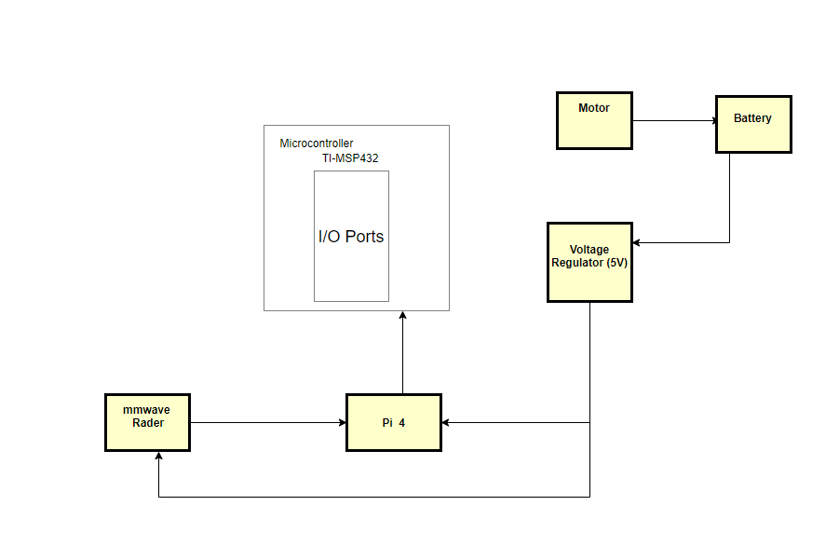

Fig. 2 System Diagram.

## System Functions

The system designed has:

1. Bump switches that edge-triggered interrupts to detect collisions
2. Line sensors that implement a simple line-following algorithm with a finite state machine (FSM)
3. A battery that powers the LaunchPad on the rover with 12V
4. A buck converter that steps down the 9v voltage battery supply to 5v and steps up the current.
5. Motor driver that allows control of large loads
6. Tachometer that calculates the speed of the RSLK by explaining the relationship between duty cycle and speed, experiencing the effect of friction.
7. Implementation Plan

## Tasks

* Task 1. RSLK Assembly
  + Subtask 1. Soldering, Assembling, and Wiring of TI RSLK Kit
  + Subtask 2. Writing and Modifying the Code for Bumps Sensors
  + Subtask 3. Writing and Modifying of the Code for Line Follow Sensor
* Task 2. Design of the computer system
  + Subtask 1. Setting up Ubuntu on the Raspberry PI 4
  + Subtask 2. Design of a power adapter for mmWave
  + Subtask 3. Implementing the mmWave interface with the microcomputer
* Task 3. Implementation and development of the mmWave sensor (IWR 1443 Boost)
  + Subtask 1. Mounting the mmWave to RSLK board
  + Subtask 2. Design and print a 3D part to help mount the mmWave
* Task 4. Acquisition of the point cloud data from the radar with the microcomputer.
  + Subtask 1. Launch the ti_mmWave_rospkg node to start the mmWave EVM
  + Subtask 2. Setting up the Ros for visualization and navigation repository
  + Subtask 3. Visualize the Radar point cloud using RVIZ
* Task 5. Upgrade of the Rover.
* Task 6. Design the autonomous navigation system of the rover.
* Task 7. Detecting and calculating the distance of an object behind the glass wall.
* Task 8. Stitching Algorithm
  + Subtask 1. Stitching the 3D point cloud data
* Task 9. System Finalization, testing, and refinement.

## Team Organization

Team member 1: Jesudara Omidokun (Engineering conc. in Electrical)

Team member 2: Aduralere Sulaiman (Engineering conc. in Computer)

### Responsibility of Team member 1

Task 1, Subtask 1.1, 1.3

Task 2, Subtask 2.1, 2.2

Task 5, Subtask 5.1, 5.2

Task 6

Task 8

### Responsibility of Team member 2

Task 1, Subtask 1.2, 1.3,

Task 2, Subtask 2.3

Task 4, Subtask 4.1

Task 6

Task 8

## Timeline/Milestones/Delivery Plan

Table . Task Assignment for Spring 2019

|  |  |  |
| --- | --- | --- |
| Time | Jesudara | Aduralere |
| Week 1 | Task 1  1.1 Soldering Components of RSLK task | Task 1  1.2 Write the code for the bump Sensors. |
| Week 2 | Task 1  1.2 Wiring Components of RSLK | Task 1  1.2 Write the code for the bump Sensors |
| Week 3 | Task 1  1.3 Assembling of RSLK Components | Task 1  1.3 Assembling of RSLK Components |
| Week 4 | Task 1  1.3 Assembling of RSLK Components | Task 1  1.3 Assembling of RSLK Components |
| Week 5-6 | Task 3  3.1 Mounting mmWave to the RSLK  3.2 3D design and printing | Task 2  2.3 Implementing the mmWave interface with the microcomputer |
| Week 7- 11 | Task 4  Acquisition of the point cloud data from the radar with the microcomputer | Task 4  4.1 Launch the ti_mmWave_rospkg node to start the mmWave EVM |
| Week 12-15 | Task 4  Acquisition of the point cloud data from the radar with the microcomputer | Task 4  Acquisition of the point cloud data from the radar with the microcomputer |
| Week 16-17 | Task 5  Modification of the rover | Task 7  Detecting and calculating the distance of an object behind the glass wall. |
| Week 18-20 | Task 6  Design the autonomous navigation system of the rover | Task 6  Design the autonomous navigation system of the rover |
| Week 21-22 | Task 9  System Finalization, testing, and refinement. | Task 9  System Finalization, testing, and refinement. |

1. Implementation

## Implementation of Task 1.

### Implementation of Subtask 1.1

This involves the use of different tools, wires, and supplies to assemble the TI-RSLK. After the RSLK parts were assembled, the final assembly looked similar to the picture in Fig. 7. The tasks for the TI-RSLK was divided into four main sections. These sections are:

* Soldering
* Assembly
* Software
* Wiring

Figures 3a and 3b show the different components (such as the chassis, heat shrink tubes, and wires) and tools used in the assembling of the RSLK.

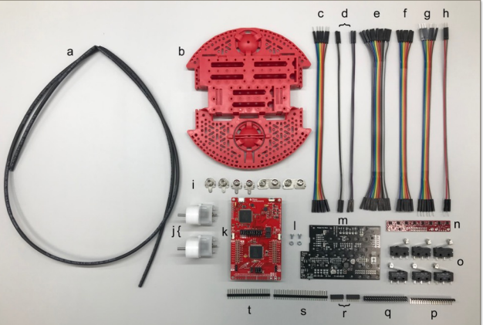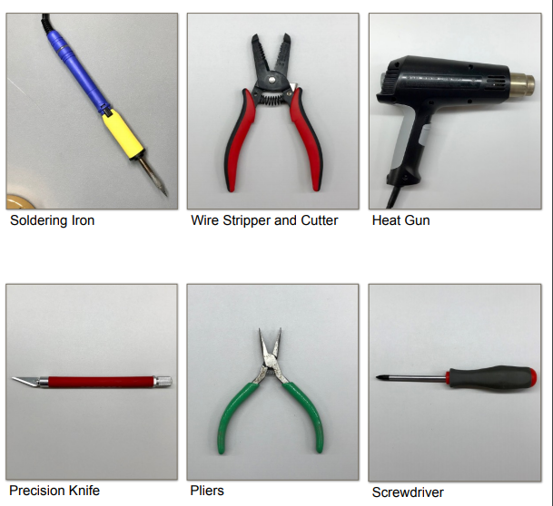

Fig. 3a Components Used in Assembling the RSLK Fig. 3b Tools Used in Assembling the RSLK

Figure 4 below shows the assembled RSLK

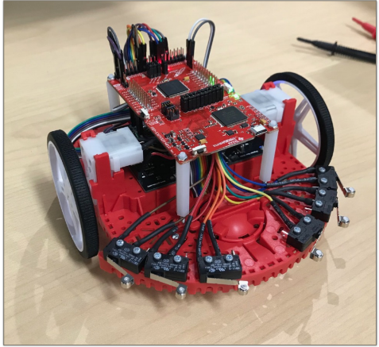

Fig. 4 Assembled TI RSLK

The components of the TI RSLK are shown in Table 3 below:

Table . Components of the Ti Rslk

|  |  |  |
| --- | --- | --- |
|  | Description |  |
| A | Heat Shrink Tube | 1 |
| B | Chassis | 1 |
| C | 6 Female to Male Wires | 1 |
| D | 2 Female to Male Wires | 4 |
| E | 11 Female to Female Wires | 1 |
| F | 6 Female to Female Wires | 1 |
| G | 6 Male to Male Wires | 1 |
| H | 2 Male to Male Wires | 1 |
| I | Battery Terminals | 1 |
| J | Motor | 2 |
| K | TI Launchpad kit | 1 |
| L | Motor Board Screw | 1 |
| M | Motor Board | 1 |
| N | Line Follower Sensor | 1 |
| O | Bump Switch | 6 |
| P | 90 Bent Header | 1 |
| Q | 2x20 Header | 1 |
| R | 1x6 Header | 1 |
| S | 1x25 Header | 1 |
| T | 1x20 Header | 1 |
| U | Motor Encoders | 2 |
| V | Bump switch wire spade connector | 12 |

* SOLDERING

A precision knife is used to cut the VPU-VREG, VCCMD-VREG, and SLP L-R traces. A deep solid cut is then made through the small line connection between the square pads. Two 1x6 female socket headers are connected to the yellow connections before connected to the 1x2 headers and then to the ELA and ELB connections. The ELA and ELB connections need to be bent to a 45-degree angle after soldering. A 1x2 header cut is made on the VPU connection. A 1x3 header is made and so is a 1x6 header cut to the left and right motor driver connections. 1x3 and 1x2 header cuts are made to the VREG terminals. The 1x8, 1x3 and 1x2 header cuts are soldered to the GND terminals. The four battery connections were soldered as part of the attachment to the chassis and the motor board was secured with two support screws. Pliers are then used to bend out the ELA and ELB & ERA and ERB connections so the connections can be attached by wires to the Launchpad.

Figure 5 shows the battery connections soldered as part of the attachment to chassis of the RSLK while figure 6 shows the LaunchPad soldered together with the pins.

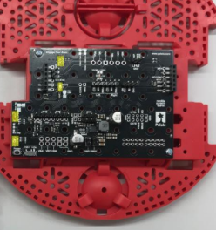 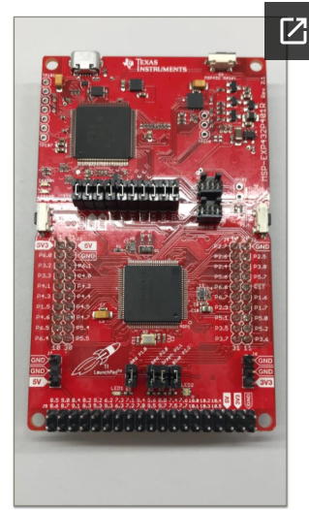

Fig. 5 Battery Connections Soldered as Part of the Chassis  Fig. 6 LaunchPad Soldered Together with

Long pins Facing Upward.

LaunchPad: The 2x19 header is then soldered on the J5 pinout at the bottom of the LaunchPad with the long pins facing upward as seen in Fig. 6. The prepared encoders are then soldered on the motors. The bump switches: one male and one female wire each is soldered to each bump sensor. This is done for the 6 bump sensors as seen in Fig. 7 while Fig 8 below shows the bump switches of the RSLK.

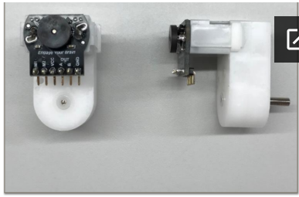 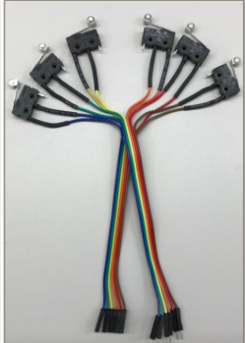

Fig. 7 Encoders Soldered to Motor Drivers.  Fig. 8 Bump Switches

* ASSEMBLING

The motors are attached to the motor board on the chassis as shown in Figure 9 and then the ball caster is then attached to the chassis before the wheels are attached as shown in Figure 10.

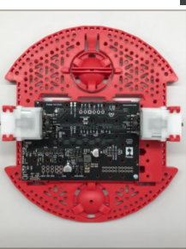 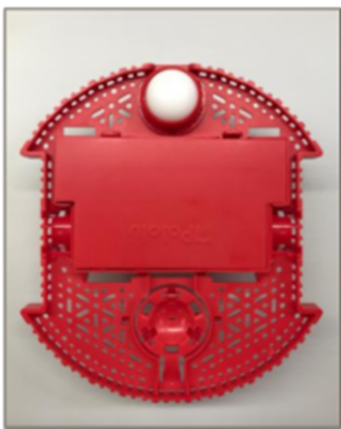

Fig.9 Motor Board on Chassis  Fig. 10 Ball Caster

Figure 11 below shows one of the wheels attached to the chassis.

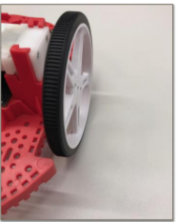

Fig. 11 Wheels of the Car

* WIRING

Figure 12 below shows the wiring of the bump switches to the LaunchPad

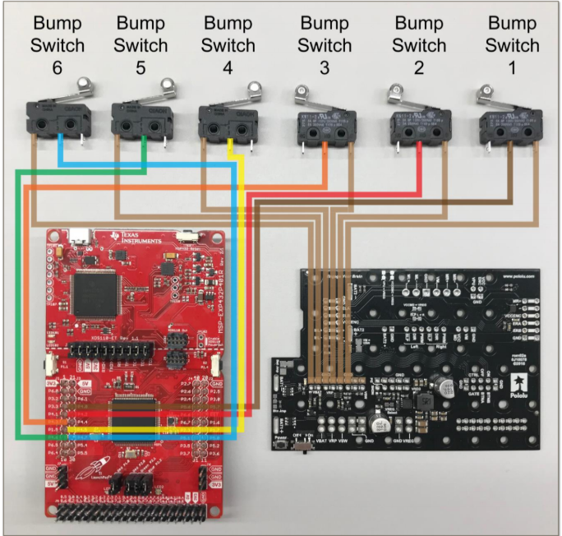

Fig. 12 Bump Switches Wiring

Table 4 below shows the connections of the bump switches to the launchpad and motor board.

Table . Bump Switches Connection Guide

|  |  |  |  |  |  |
| --- | --- | --- | --- | --- | --- |
|  | Bump 1 | Bump 2 | Bump 3 | Bump 5 | Bump 6 |
| LaunchPad | P 4.0 | P.4.2 | P.4.5 | P.4.6 | P 4.7 |

Figure 13 shows the connection between the motor board and the LaunchPad.

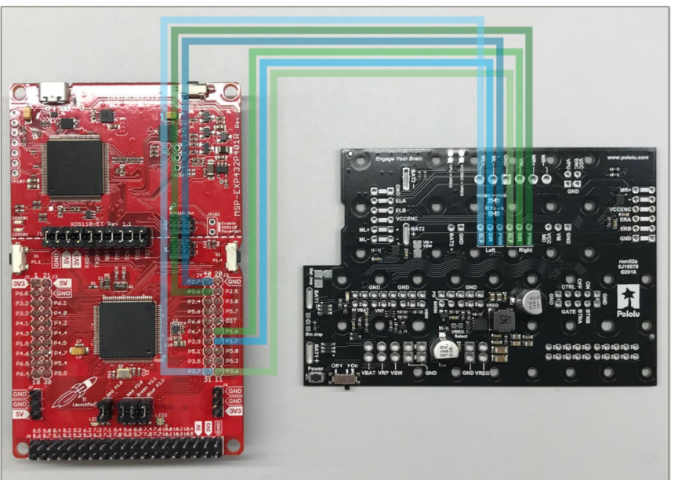

Fig. 13 Motor Board Wiring to LaunchPad

Table 5 shows the wiring between the motor board and the LaunchPad

Table . Motor board Wiring Guide

|  |  |  |  |  |  |  |
| --- | --- | --- | --- | --- | --- | --- |
| Motor Board | Left SLP | Left DIR | Left PWM | Right SLP | Right DIR | Right PWM |
| Launchpad | P3.7 | P1.7 | P2.7 | P3.6 | P1.6 | P2.6 |

Table 6 shows the wiring of the motor board from the ground and from VReg.

Table . Motor board Wiring From Ground And Vreg

|  |  |  |
| --- | --- | --- |
| Motor Board | VREG | GND |
| Launchpad | 5V | GND |

Figure 14 below shows the wiring guide of the Line Sensor

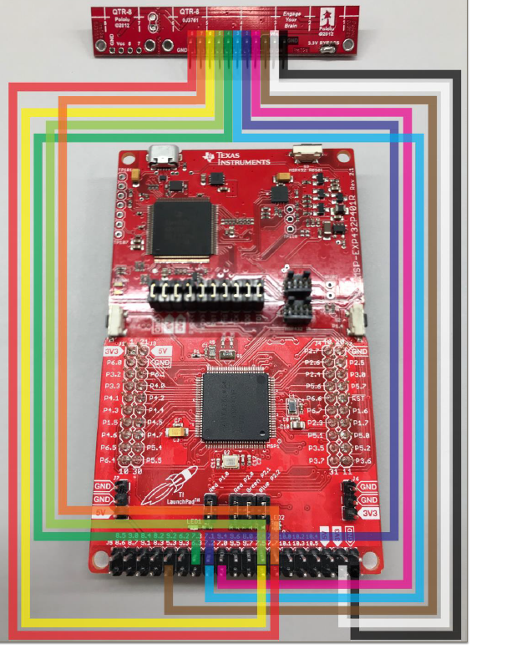

Fig. 14 Line Sensor Wiring Guide

Table 7 shows the wiring between the Line Sensor and the LaunchPad

Table . Line Sensor Wiring Guide

|  |  |  |  |  |  |  |  |  |  |  |  |
| --- | --- | --- | --- | --- | --- | --- | --- | --- | --- | --- | --- |
| Line Sensor | 8 | 7 | 6 | 5 | 4 | 3 | 2 | 1 | LED ON | VCC | GND |
| Launchpad | P7.7 | P7.6 | P7.5 | P7.4 | P7.3 | P7.2 | P7.1 | P7.0 | P5.3 | 3V3 | GND |

* SOFTWARE

The steps to get the software working were:

1. Install CCS (Code Composer Studios)
2. Import the TI Drivers
3. Download RSLK Energia Library

* TROUBLESHOOTING
* Soldering:

The first issue encountered when soldering was having to solder the connectors upside down as this affected the wiring because the female connector wire removed due to the fact that the pins have different diameter from top to bottom. The solution to this issue was to de-solder the connectors and then re-solder.

Another issue that was encountered when soldering was with the encoders. The encoder connector pins are flexible which made to fragile. During the attachment of the motor board to the motor, an encoder pin broke causing the motor to stop working. The solution to this issue was to de-solder the encoder and find a less fragile pin and connector to use.

The motor also had a similar issue, but the only solution was to buy another motor.

* Assembly:

The main issue when assembling the parts was from the chassis motor clips. The chassis motor clips from the TI RSLK kit didn’t sit well on the chassis. The solution to this issue was to break part of the motor clips in order to fit the motors. The motors were then slid into the motor clips without over-stressing the clips.

* Software:

One of the challenges was installing CCStudio on the computer. Different errors occurred during the installations.

Figure 15 shows the error messages received while Figure 16 shows the antivirus being switched off.

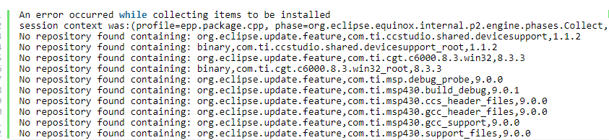

Fig. 15 Error Message Received

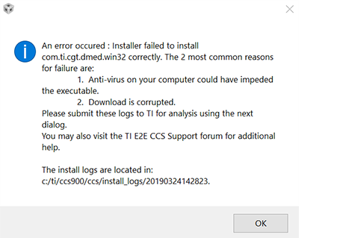

Fig. 16 Switching off the Antivirus

This problem was then solved by turning off the antivirus on the computer before the installation. After the RSLK parts were assembled, the final assembly in Figure 17 is shown below:



Fig. 17 Assembled TI RSLK

### Implementation of Subtask 1.2

For this task, the assembling of the bump switches and the codes were written and compiled for the six bump switches. The following are used:

1. 6 bump switches
2. 12 Heat shrink tubes that are already cut
3. 6 female wires with one end cut and stripped
4. 6 male wires with one end cut and stripped

The first step in attaching the bumper switches to the TI RSLK is to slide the heat shrink tubes that are already cut on each female wire. Next, solder one female wire on the “1” or “C” connection on each bump switch. After soldering the bump switches on the female wires, heat shrink tubes are slid on 6 male wires. Lastly, solder one male wire on the “3” or “NO” connection on each bump switch (0). Color coding each switch will helps later when wiring. The codes for the bump switches can be found in the appendix section source code.

### Implementation of Subtask 1.3

For this task, the code for the line tracker was written and compiled. The RSLK has two-line sensors one on the left and one for the right. The RSLK has two motors.

For the two sensors (left-right)

1 1 explains that the RSLK is on the line

1 0 explains that the RSLK is off to the right

0 1 explains that the RSLK is off to the left

0 0 explains that the RSLK is lost

If the car detects black lines when there is a white line the RSLK would only go through the white lines. The line sensor follows black lines only. The motor driver runs the finite state machine every 50 microseconds. The flow chart in Fig. 18 summarizes the code. The source code for the line tracker can be found in the Appendix section under source code 1.

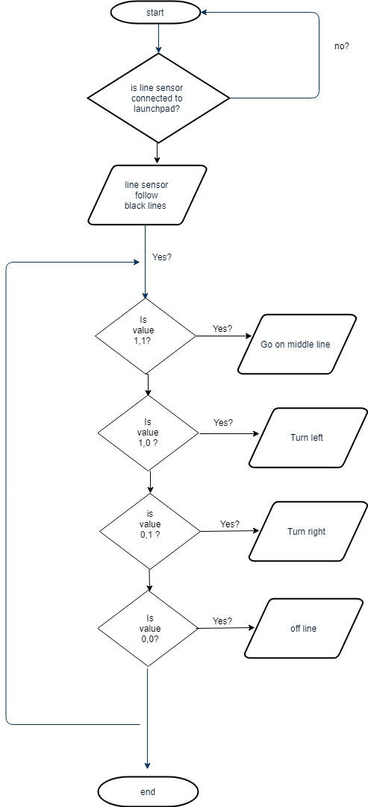

Fig. 18 Flow Chart for Line Sensor

## Implementation of Task 2.

### Implementation of Task 2 Subtask 1

Raspberry pi 4 is a new microcomputer so it has no official ubuntu operating system desktop and the pervious ubuntu operating system desktop image cannot work on it. However, the ubuntu operating server that is currently used was provided by James Chambers with the unofficial Operating server the Ubuntu operating Desktop image was created.

The process of creating ubuntu operating system is as follows:

* Visit the <https://github.com/TheRemote/Ubuntu-Server-raspi4-unofficial/releases/tag/v12>.
* Download the ubuntu 18.04.3 preinstalled server-arm64.
* Extract and use Win32Diskmanger to burn it as a bootable drive on an SD card.
* Download the source code and copy the extracted data to the bootable SD card space.
* Plugin in SD card to the pi 4 and make sure to connect to an ethernet cable.
* Login to the pi using ubuntu as a username and password.
* Run the commands shown below:

sudo apt-get update

sudo apt-get upgrade

sudo apt-get install xubuntu-desktop # or

sudo apt-get install kubuntu-desktop

The reasons to use Ubuntu as the operating system on the microcomputer are as follows:

* Ubuntu is an open source operating system that can be used on various microcomputers.
* Ubuntu is very user friendly compared to other operating systems such as RISC OS and Pidora.
* Ubuntu is also very secure, so there is no need for the installation of any antiviruses.
* Ubuntu is also customizable and can be personalized upon download.
* Ubuntu has a strong community support which is one of the biggest advantages.

### Implementation of Task 2 Subtask2

For this task, an LM2596 (buck converter) which steps down converter is also which DC-DC power converter which steps down voltage and steps up current to 2.5 Amp from the input voltage of 9 volts to the output load 5 volts. There is a potentiometer that regulates an output voltage to a voltage of 5. Figures 19 and 20 below show the power supply and schematics of a buck converter.

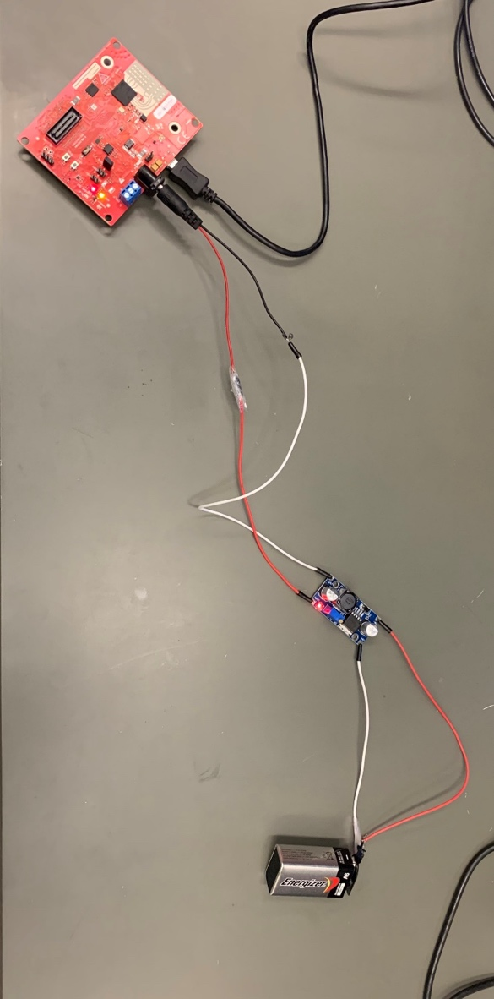

Fig. 19 5V Power Supply

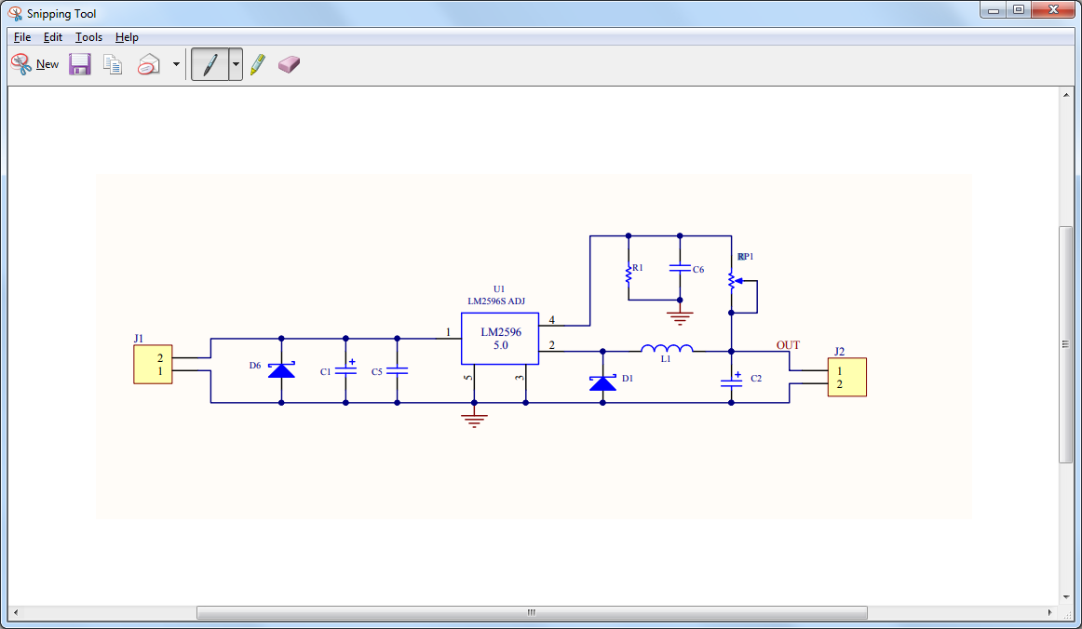

Fig. 20 Schematics of Buck Converter

### Implementation of Task 2 subtask 3

For this task, Ubuntu 16.04 64bits was installed to enable the ROS library. After downloading Ubuntu, an Ubuntu drive was created to enable booting from a USB drive. Shrinking the windows 10 partition to make space was Ubuntu, boot into Ubuntu live environment and install Ubuntu.

## Implementation of Task 3

### Implementation of Task 3 Subtask 1

The mmWave sensor was mounted unto the RSLK to provide the geographical information such as velocity, angle and 3D imaging as stated in the objective. However, as a new rover was implemented, there are no pictures of the mmWave sensor on the RSLK.

### Implementation of Task 3 Subtask 2

Using SolidWorks, an L-shaped mount was designed for the mmWave sensor. This mount was supposed to prevent problems such as power surge.

Figure 21 below shows the L-shaped mount which was designed for the mmWave sensor.

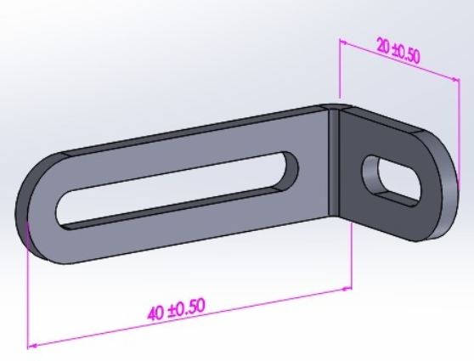

Fig. 21 L-shaped mount

## Implementation of Task 4

### Implementation of Task 4 subtask 1

The IWR1443 BoosterPack™ is an easy-to-use evaluation board for the single-chip IWR1443 mmWave sensing device from TI, with direct connectivity to the TI MCU LaunchPad™ ecosystem. The evaluation board contains everything needed to start developing on a low-power ARM®-R4F controller. The evaluation board includes onboard emulation for programming and debugging onboard buttons, and LEDs, for quick integration of a simple user interface. The standard 20-pin BoosterPack headers make the evaluation board compatible with a wide variety of TI MCU LaunchPads and enable easy prototyping.

Some specs of the mmWave are:

1. XDS110-based JTAG emulation with serial port, for onboard QSPI flash programming
2. Backchannel UART through USB to PC, for logging purposes
3. Onboard antenna
4. 4 receivers and 3 transmitters
5. 40-pin Launchpad standard that leverages the Launchpad ecosystem.

Some key features of the mmWave are:

1. One button and two LEDs, for user interaction, 5-V power jack, to power the board
2. On-Chip Programmable Core for Embedded User Application
3. Radio processor for built-in Calibration and Self-Test
4. Backchannel UART through USB to PC, for logging purposes

Figure 22 and 23 below show the different views of the IWR1443

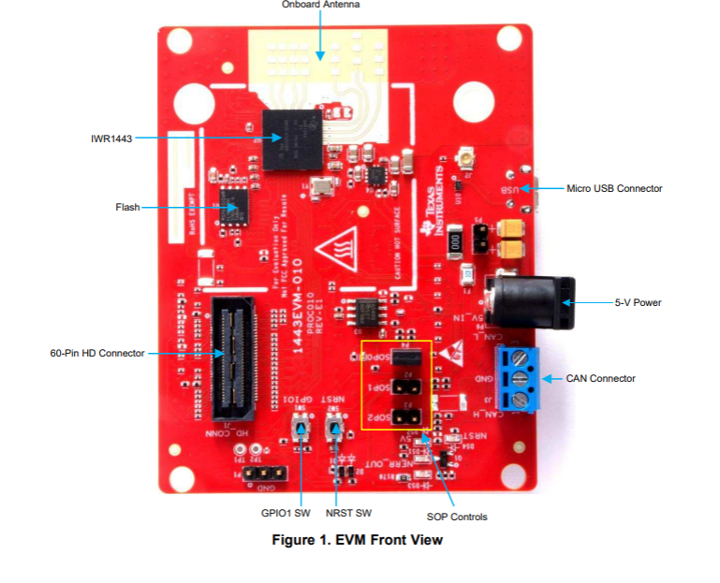 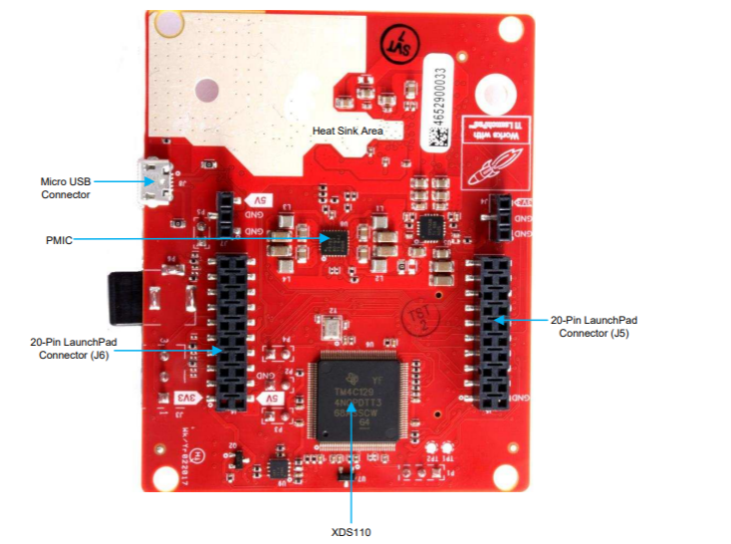

Fig. 22 Front view of the IWR1443  Fig. 23 Back view of the IWR 1443

Figure 24 below shows the block diagram of the mmWave sensor

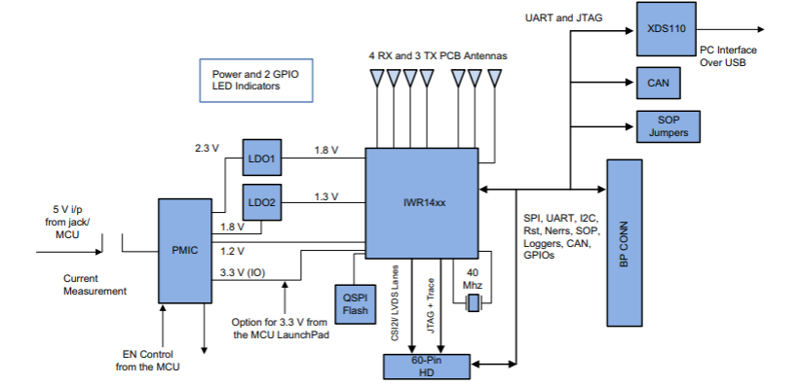

Fig. 24 Block diagram of the IWR1443

To launch the ti_mmWave_rospkg node to start the mmWave EVM, the following steps were taken:

1. Use GIT to download (clone) the ROS serial driver into your /src directory: $ cd /src $ git clone <https://github.com/wjwwood/serial.git>. More documentation on this library can be found at http://wjwwood.io/serial/ TI mmWave ROS Driver Setup Guide Version 1.5 6 3.
2. Download the TI mmWave ROS Driver (ti_mmwave_rospkg) and copy it to your /src.
3. After opening the ti_mmave_rospkg_.zip file, see the ti_mmwave_rospkg. Open a new file browser and navigate to your /src directory. Copy the ti_mmwave_rospkg folder to the /src directory.
4. Build your project: In the Terminal/shell, go to your directory and build the driver: $ cd $ catkin_make.
5. Flash the mmWave using the UniFlash
6. Launch the TI mmWave ROS node and Rviz visualizer by running $ rosrun rviz rviz.

### Implementation of Task 4, Subtask 2

The Robot Operating System (ROS) is a flexible framework for writing robot software. It is a collection of tools, libraries, and conventions that aim to simplify the task of creating complex and robust robot behavior across a wide variety of robotic platforms. mmWave FMCW Radar chirp profile through command-line interface (CLI) on a UART port, Do 1D, 2D, CFAR, Azimuth and Elevation processing and stream out intensity, relative radial velocity and three spatial coordinates (x,y,z) of the detected objects in real-time. Because the ROS framework and libraries support point cloud data, ROS is useful for developing and prototyping with the mmWave EVMs for robotics applications.

Some of the core components of ROS include:

* Communications Infrastructure
* Message Passing
* Remote Procedure Calls
* Distributed Parameter System

In addition to the core middleware components, ROS provides common robot-specific libraries and tools that will get your robot up and running quickly. Here are just a few of the robot-specific capabilities that ROS provides:

* Standard Message Definitions for Robots
* Robot Geometry Library
* Robot Description Language
* Diagnostics
* Localization
* Installing the ROS (Robotic Operating System)

The ROS kinetic Kame was selected among the two distribution that is commonly used now. The prerequisites for install ROS kinetic kame are installed bootstrap dependencies, installing ROSDEP. The Installing Building the catkin Packages, Create a catkin workspace, Set up your keys, Install a Debian package that contains(ROS, rqt, rviz, robot-generic libraries, 2D/3D simulators, navigation, and 2D/3D perception and Environment setup under the ROS Workspace note install the rosbuild Not catkin.

The process for installing the Operating System is as follows:

1. Install the ROS ‘serial’ package:
2. Use GIT to download (clone) the ROS serial driver into your /src directory: $ cd /src $ git clone <https://github.com/wjwwood/serial.git>. More documentation on this library can be found at http://wjwwood.io/serial/ TI mmWave ROS Driver Setup Guide Version 1.5 6 3.
3. Download the TI mmWave ROS Driver (ti_mmwave_rospkg) and copy it to your /src.
4. After opening the ti_mmave_rospkg_.zip file, see the ti_mmwave_rospkg. Open a new file browser and navigate to your /src directory. Copy the ti_mmwave_rospkg folder to the /src directory.
5. Build your project: In the Terminal/shell, go to your directory and build the driver: $ cd $ catkin_make.
6. Flash the mmWave using the UniFlash
7. Launch the TI mmWave ROS node and Rviz visualizer by running $ rosrun rviz rviz.

The ROS Kinetic Kame was supposed to be used because most of the ROS mmWave library was design for the ROS Kinetic Kame but the ROS Kinetic Kame cannot be installed on ubuntu 18.04 only 16.04 so the new ROS package was installed ROS Melodic Morenia.

The ROS Melodic Morenia was selected among the two distribution that is commonly used now. Visit for the installation <http://wiki.ros.org/melodic/Installation>. The prerequisite to install ROS Melodic Morenia was to install bootstrap dependencies, installing ROSDEP. Install the catkin Packages, Create a catkin workspace, Set up your keys, Install a Debian package that contains(ROS, rqt, rviz, robot-generic libraries, 2D/3D simulators, navigation, and 2D/3D perception and Environment setup under the ROS Workspace note install the rosbuild Not catkin.

Installation of the ROS ‘serial’ package

* Troubleshooting

The main issue faced was when flashing the IWR1443 device with UniFlash.

The solution can be seen below in Figure 25

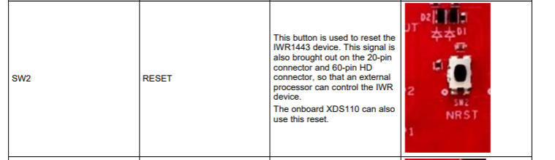

Fig. 25 Solution to the Issues Encountered

After facing multiple problems in the previous semester with the ODRIOD XU4Q, a different microcomputer was purchased to continue the project with (PINE A64). The PINE A64 seemed like a better option as it is a single-board computer powered by quad-core ARM Cortex with Mali 400 MP2 GPU. As ROS runs on Ubuntu 16.04 LTS operating system, Ubuntu operating system had to be built for PINE A64. The steps to build the operating system are as follows:

1. Setting up the Development Environment

2. Getting Something to Boot

3. Organizing the Project

4. Wrangling Memory

5. Dynamic Memory Allocator

6. Printing to a Real Screen

7. Interrupts

8. Processes

9. Locks

10. Virtual Memory

Upon completion of the installation of the Ubuntu on the PINE A64, errors began to occur. The main issue was on partitioning the SD card. Another issue was that most of the files needed for the ROS to function could not be installed. Another error that occurred was an update error. The error “Failed to download repository information” was another error when trying to run Ubuntu on the PINE A64 as seen below in Figure 26

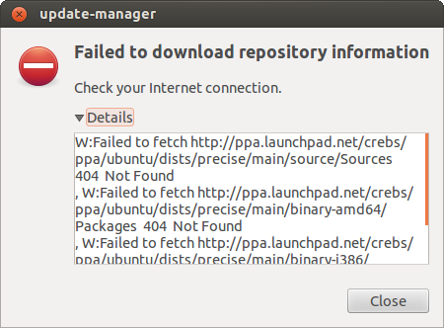

Fig. 26 Error Message showing the failed to download repository information

The main browser (chromium) was also unable to be installed properly on to the PINE A64 as shown in Fig 27.

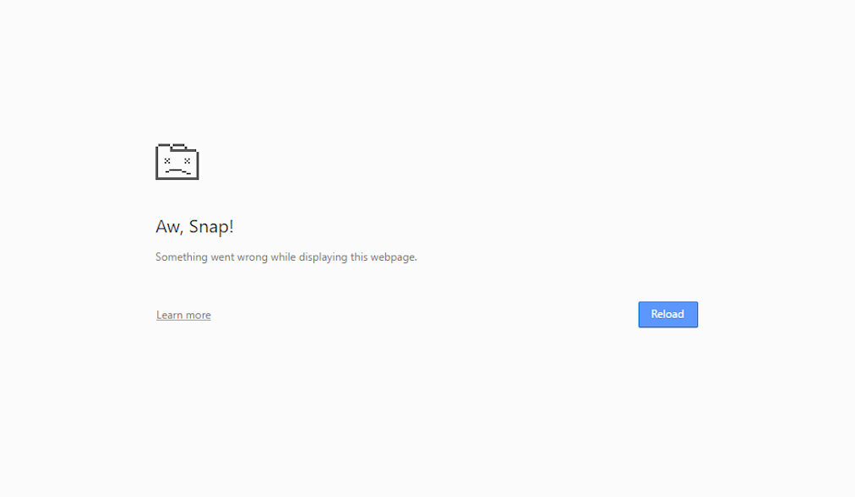

Fig. 27 Aw, Snap error shown on chromium

After deliberations and looking for solutions on how to move forward with the project, a raspberry pi 4 was later purchased to make headway in the project.

### Implementation of Task 4, Subtask 3

To generate a point cloud from mmWave with a Robotic Operating System, the following requirements are needed:

* Host PC (laptop or desktop)
* TI mmWave 1443 ES3.0 EVM
* USB to microUSB cable
* 5VDC power supply (center positive barrel jack, 2.5A)
* Ubuntu 16.04 LTS operating system
* Robot Operating System (ROS)
* ti_mmwave_rospkg source code
* mmWave SDK software
* UniFlash

The steps to visualize the point cloud data are as follows:

1. Install bootstrap ROSDEP on PC
2. Install ROS kinetic kame
3. Create Workspace
4. Create the ROS workspace environment
5. Install ti_mmwave_rospkg_zip ROS driver
6. Flash mmWave using UniFlash
7. Import radar file provided by TI
8. Generate the point cloud data using rosrun rviz rviz

Before visualizing the point cloud data on the ROS Visualizer, some parameters can be tweaked to improve the point cloud data. Some of these parameters are:

* Range Resolution
* Frame Rate
* Maximum Radial Velocity
* Radial Velocity Resolution

Figure 28a and 28b below shows the Parameters of the visualizer

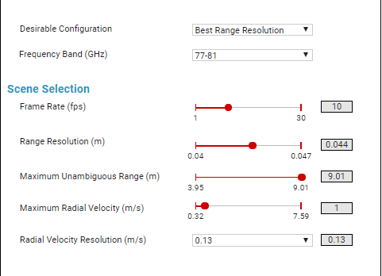 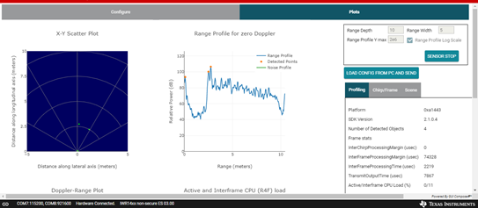

Fig. 28a shows the parameters of the visualizer Fig. 28b shows the plot and profile after altering the parameters

Figures 29a and 29b below show the ROS Visualizer, without the point cloud data and with the point cloud data.

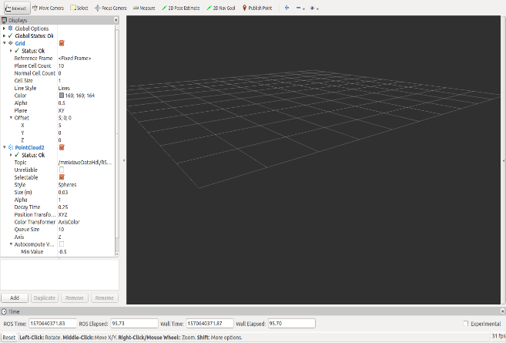 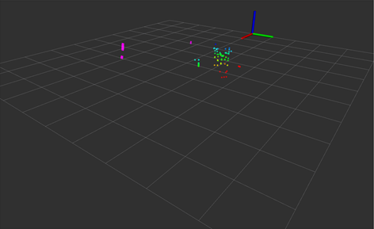

Fig 29a. ROS Visualizer Fig 29b. ROS Visualizer with point cloud data

After tweaking the parameters such as Frame Rate and Resolution the point cloud data becomes more clear. Figure 30 below shows the point cloud data on the visualizer when the mmWave sensor was sensing a tree beyond a glass wall.

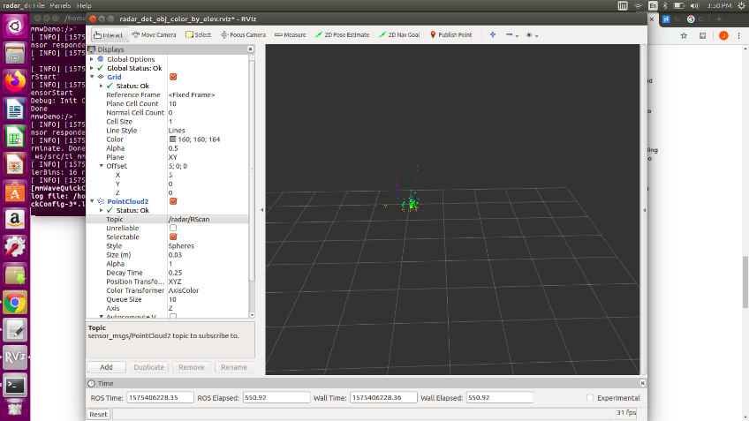

Fig. 30 Point cloud data of a tree beyond a glass wall

## Implementation of Task 5

The RSLK was changed because its size and weight will not be suitable for the final design when mounting the sensors needed. For the new rover, the motor drive, tires, and chassis are changed to accommodate a more stable weight and size for the total application. Figure 35 shows the L298 Dual H-Bridge Motor Driver which was used in place of the TI motor drive in Figure 5. The H-bridge motor driver is ideal for the project because it allows the implementation of four motors.

The new rover will have the following components:

1. L298 Dual H-Bridge Motor Driver
2. Four motors
3. Four wheels
4. mAh batteries to power the motor
5. Power bank to power the mmWave
6. mmWave
7. Three chassis
8. Raspberry PI 4

Figures 31, 32 and 33 show the new components of the rover.

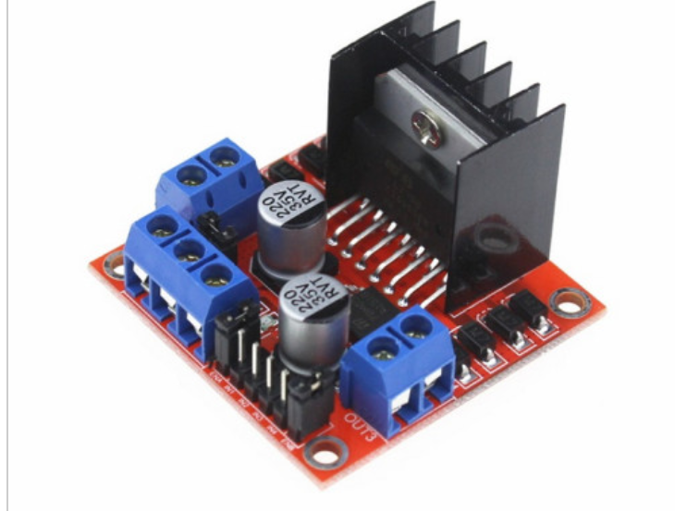 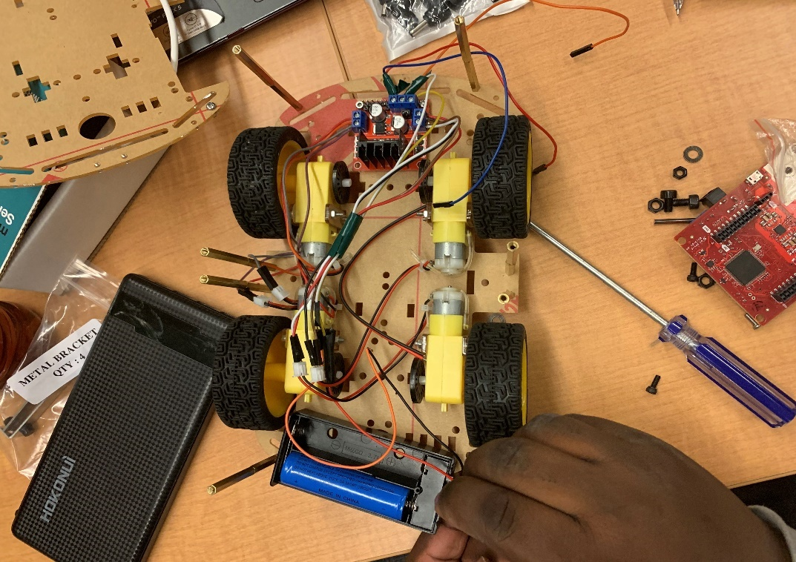

Fig. 31 L298 Dual H-Bridge Motor Driver Fig. 32 Chassis of Rover

After the rover is programmed to be able to move correctly, a chassis is fixed parallelly on the rover. On this first chassis, the mmWave is then fitted on this chassis. Another chassis is then fixed above to hold the power bank and microcomputer in place.

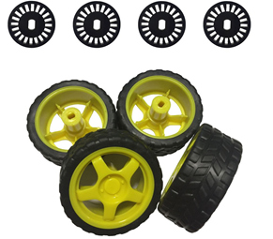 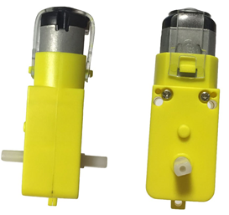 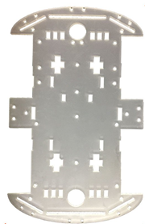

Fig. 33 New components of Rover

The new rover was then assembled with the various components stated above. With most of the components assembled to the new rover, the payload of the rover was calculated.

Figures 34 below show the payload being determined

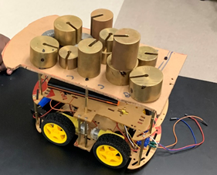 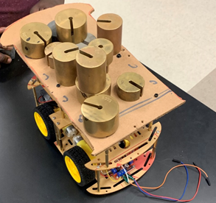

Fig. 34 Rover with weights

After the payload was determined, the mmWave sensor was then assembled to the rover to achieve the final model. Figures 35 shows the final model of the rover

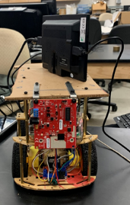 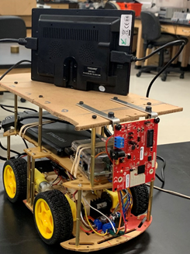

Fig. 35 Final Model of Rover

## Implementation of Task 6

Figure 36 below shows the interaction of a Turtlebot with the ROS visualizer

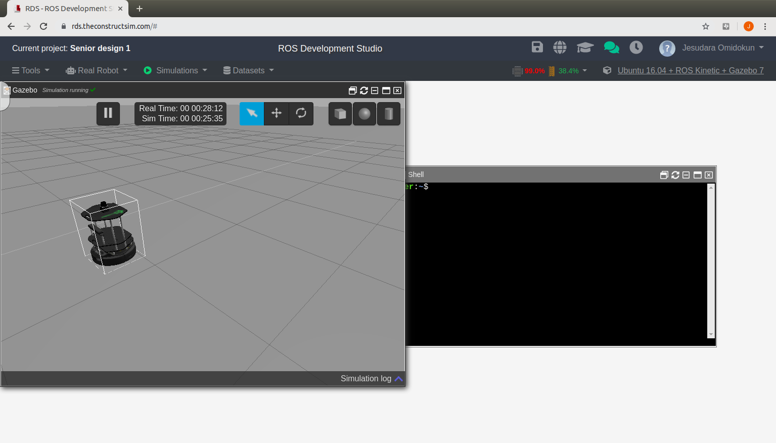

Fig.36 Interaction of Turtlebot on ROS

For the navigation of the rover, Remote Desktop Access was used so that the data from the microcomputer can be accessed remotely on a personal computer. A software called Remmina was used to achieve the Remote Desktop Access

The commands to generate Remote Desktop Access on a personal computer are as follows:

sudo apt-get update

sudo apt install vim

sudo apt install git

sudo apt install openssh-server

sudo ufw allow 22

sudo systemct1 enable ssh

sudo systemct1 start ssh

whoami

ifconfig

sudo apt install xrdp

sudo spt remmina

Figure 37 shows the Remote Desktop Access

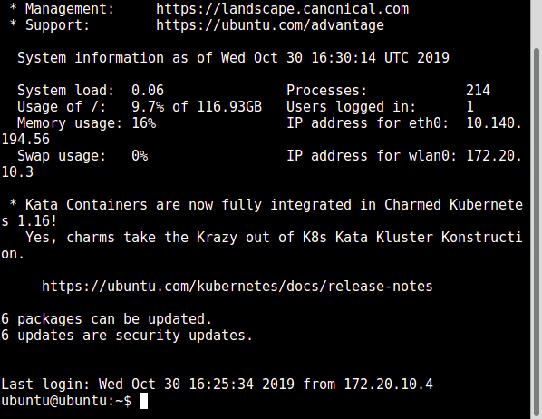

Fig. 37 Remote Desktop Access

## Implementation of Task 7

Object detection behind glass walls is one of the prominent features of the mmWave sensor. This feature is important because of the prevalence of glass in architecture today. Partition glass and glass, in general, is a problem for vision and IR based sensors in robotics. The mmWave sensor can detect both the glass walls and the objects behind to avoid collisions. The mmWave sensor can also detect various objects from various angles.

Figure 38 below shows the different angles of objects that can be detected by the mmWave against the glass wall.

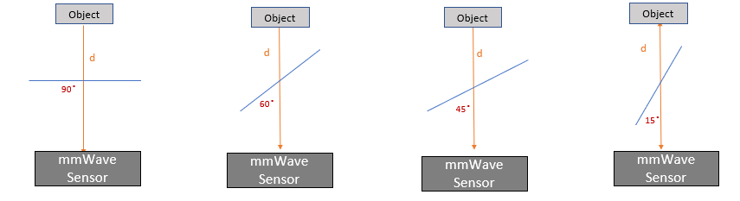

Fig 38. Angle detection by the mmWave sensor

Figure 39 below also shows the Range Profile of the object and wall detected at a 90-degree angle.

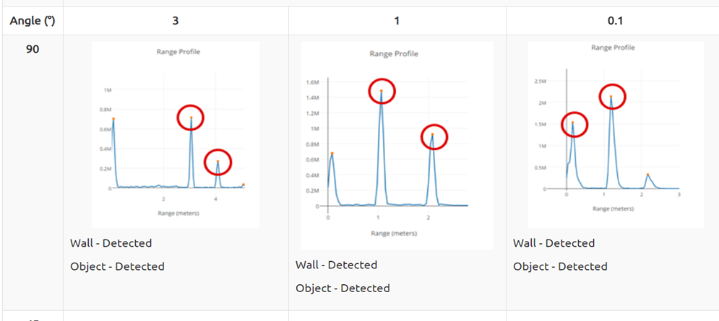

Fig 39. Range Profile of the object and wall

Figures 40a, b and c below display the mmWave sensor detecting a tree beyond a glass wall

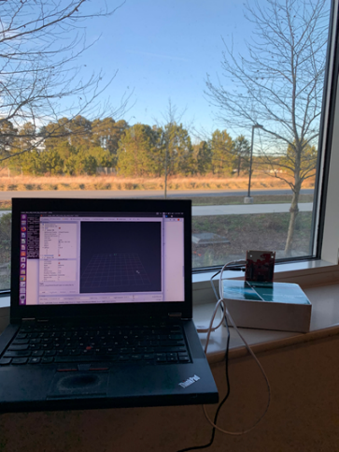 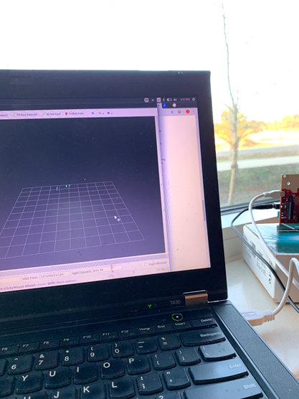 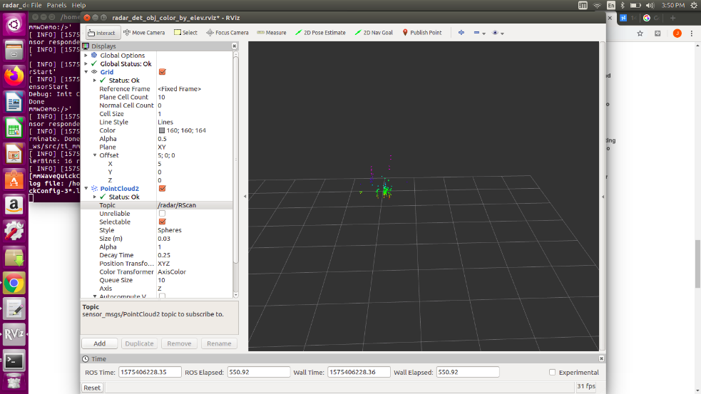

Fig 40a, b and c displaying the tree detected beyond a glass wall

## Implementation of Task 8.

**The sititching of data using octmap and map**

The microcomputer (raspberry pi) uses the ROS software libraries. The mmwave sensor then interfaces with the Raspberry Pi and then publishes the radar scan data, which is received by subscribing the same ROS Topic in Matlab ROS Package.

Binary occupancy grid can be generated and prompts to choose the destination in the Map

By using PRM (Probabilibitic Road Map) algorithm, with the number of nodes and length of connecting node distance path can be generated from the starting point to the destination point.

The steps used to generate the map are as follows

1. Launch the Gazebo world using

roslaunch mybot_world.launch.

1. Start map building using

roslaunch mybot_navigation gmapping.launch

1. Lauch rviz so as to set the parameters:

roslaunch mybot_description mybot_rviz_gmapping.launch

1. Start teleop for autonoums naviation of the rover.

roslaunch mybot_navigation mybot_teleop.launch.

**Saving the Map**

Create the path to save the data the path to save was created on the naviagation folder under the catkin workspace created for ros using the following codes:

rosrun map_server map_saver -f ~/mybot_ws/src/mybot_navigation/maps/testmap.

roslaunch mybot_ mybot_rviz_amcl.launch

roslaunch mybot_gazebo mybot_world.launch

roslaunch mybot_navigation amcl_demo.launch

**Loading the Map in MATLAB**

The xyz data is then imported on map. The matlab code used is in the appendix.

Fig 41 shows the result generated from matlab.

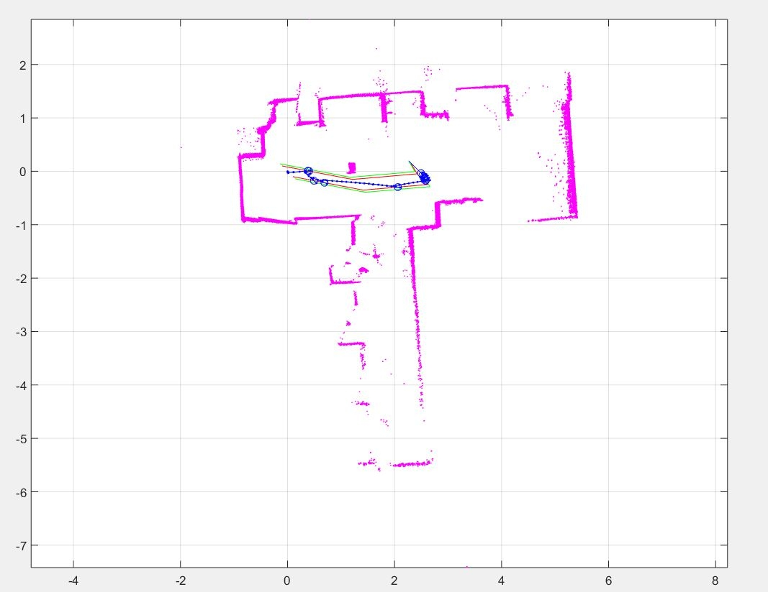

Fig.41 Image of data stitched using matlab. 2D plot.

## Implementation of Task 9

Most of the design requirements were met. According to the design requirements, the rover must be able to provide visual data in the form of 3D point cloud data. As shown in figures 29a, b and c, point cloud data can be acquired. This point cloud data was displayed using the ROS visualizer and was used for other tasks such as the detecting of an object behind a glass wall. The next requirement was to avoid obstacles.

Using the fairly new mmWave sensor by TI, the rover was able to avoid obstacles to a certain extent. As shown in videos during the presentation, the rover was able to stop when objects were within it’s detection range. However, the rover was unable to fully process information after stopping such as moving to the left or right of the object detected. The payload of the rover was also determined as shown in figure 34.

When changing the main structure of the rover from the RSLK that was used in the previous semester, battery was particularly an issue as the rover will have to run for hours before it can be recharged.

Figure 42 below shows the rover tested with 24000mAh power bank

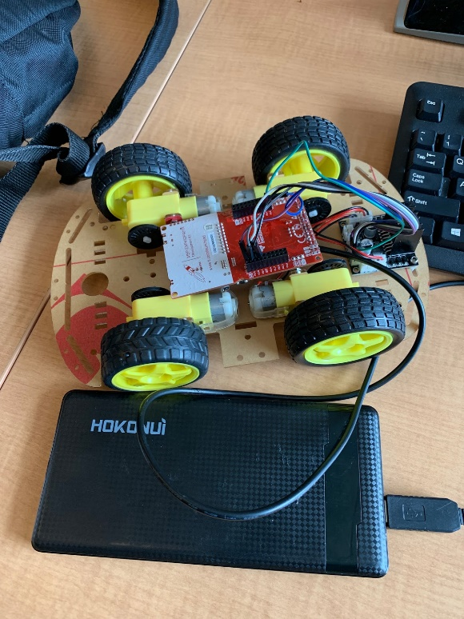

Fig 41. Rover with power bank

After the finalizing the structure of the rover and testing it, the final designs are as seen in the figures below.

Figure 42 below shows the final design of the rover

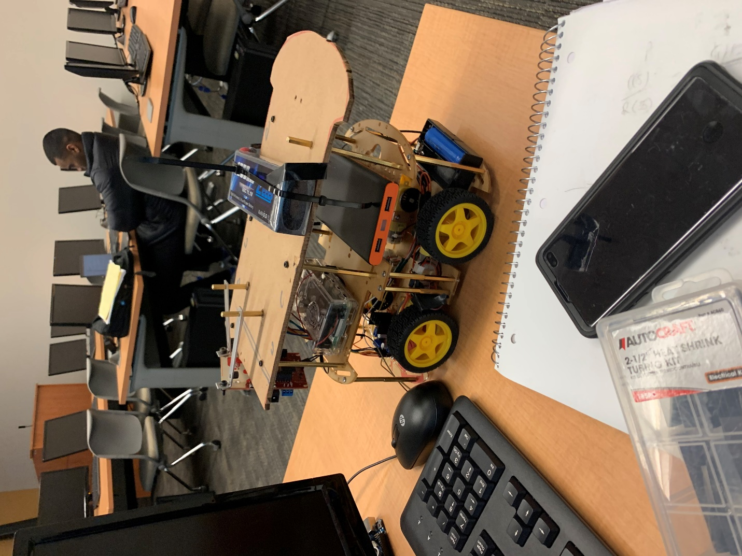 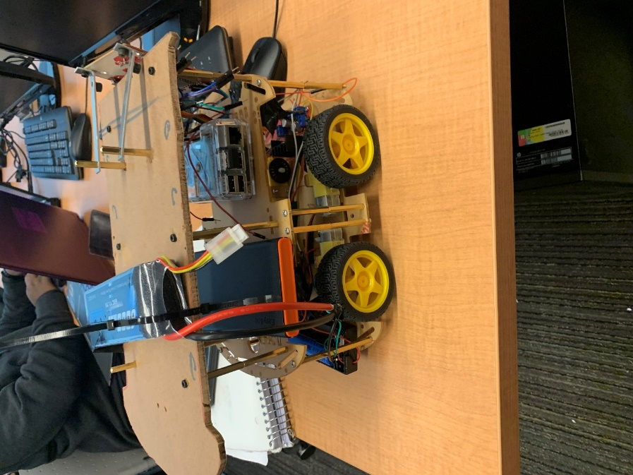

Fig 42 shows the final version of the rover

**Conclusion**

Working on this design project was an unforeseeable journey. A lot was learnt while working on this project. There were a lot of uncertainties down the line. Working with a microcomputer and the mmWave sensor proved to be difficult. For the project, the right microcomputer had to be used so that the mmWave sensor would interface smoothly with the microcomputer. An ODROID XU4 was initially purchased to perform as the microcomputer. However, this proved to be too difficult to use. A PINE A64 was then purchased but there will still many complications. As the mmWave uses many of TI’s nodes which had to be downloaded using chrome, the PINE A64 proved to be almost useless. Eventually, after a lot of tries and errors, we stumbled upon the raspberry pi 4.The raspberry pi 4 proved to be very adequate but difficult as it is still a fairly new microcomputer and there is still a lot of unreleased information.

Working with the mmWave sensor was also a hassle as it is also still a fairly new technology. There was a little assistance from TI as they helped replace a sensor which stopped working in the previous semester. However, when it came to some information or aid about the sensor, they couldn’t help too well and a lot had to be figured out.

A lot was learnt during the course of this project which was very exciting. One section about the project that was very interesting was the many uses of ROS. Hopefully one day, there will be more opportunities to work on robots and ROS.

Appendix

1. Source Code.
2. Source Code of Line Sensor

struct State {

uint32_t out; // 2-bit output

uint32_t delay; // time to delay in 1ms

const struct State *next[4]; // Next if input is 0-3

};

typedef const struct State State_t;

#define Center &fsm[0]

#define Left &fsm[1]

#define Right &fsm[2]

StateType fsm[3]={

{0x03, 500, { Right, Left, Right, Middle }},

{0x02, 500, { Left, Middle, Right, Middle }},

{0x01, 500, { Right, Left, Middle, Middle }}

};

State_t *Spt;

uint32_t Input;

uint32_t Output;

int main(void){ uint32_t heart=0;

Clock_Init48MHz();

LaunchPad_Init();

TExaS_Init(LOGICANALYZER);

Spt = Middle;

while(1){

Output = Spt->out;

LaunchPad_Output(Output);

TExaS_Set(Input<<2|Output);

Clock_Delay1ms(Spt->delay);

Input = LaunchPad_Input();

Spt = Spt->next[Input];

heart = heart^1;

LaunchPad_LED(heart);

}

}

1. Source Code of Bump Switches

void Poll(void){// 10 ms

if(P6->OUT&0x04){

SW1 = 1;

}

if(P6->OUT&0x08){

SW2 = 1;

}

}

int main(void){

Clock_Init48MHz();

P6->DIR &= ~0x0C;

TimerA2_Init(&Poll, 5000);

EnableInterrupts();

while(1){}

}

void VectorButtons_Init(void){

P5->SEL0 &= ~0x08;

P5->SEL1 &= ~0x08;

P5->DIR &= ~0x08;

P5->IES &= ~0x08;

P5->IFG &= ~0x08;

P5->IE |= 0x08;

NVIC->IP[9]=(NVIC->IP[9]&0x00FFFFFF)|0x40000000;

NVIC->ISER[1] = 0x00000080;

P6->SEL0 &= ~0x08;

P6->SEL1 &= ~0x08;

P6->DIR &= ~0x08;

P6->IES &= ~0x08;

P6->IFG &= ~0x08;

P6->IE |= 0x08;

NVIC->IP[10]=(NVIC->IP[10]&0xFFFFFF00)|0x00000040;

NVIC->ISER[1] = 0x00000100;} // interrupt 40

void PORT5_IRQHandler(void){

P5->IFG &= ~0x08;

SW1 = 1;

}

void PORT6_IRQHandler(void){

P6->IFG &= ~0x08;

SW2 = 1;

}

1. Source Code of 4k FFT Stiching Algorithm

#include <stdint.h>

#include <stdlib.h>

#include <stddef.h>

#include <string.h>

#include <stdio.h>

/* BIOS/XDC Include Files. */

#include <xdc/std.h>

#include <xdc/runtime/System.h>

#include <ti/drivers/hwa/hwa.h>

#include "config_hwa_util_4k_fft.h"

#include "data_path_4k_fft.h"

#include "mmw.h"

extern mmwHwaBuf_t gMmwHwaMemBuf[MMW_HWA_NUM_MEM_BUFS];

uint32_t log2Approx(uint32_t x)

{

uint32_t idx, detectFlag = 0;

if ( x < 2)

{

return (0);

}

idx = 32U;

while((detectFlag==0U) || (idx==0U))

{

if(x & 0x80000000U)

{

detectFlag = 1;

}

x <<= 1U;

idx--;

}

if(x != 0)

{

idx = idx + 1;

}

return(idx);

}

void HWAutil_configRangeFFT(HWA_Handle handle,

uint32_t paramSetStartIdx,

uint32_t numAdcSamples,

uint32_t numRangeBins,

uint8_t numRxAnt,

uint32_t windowOffsetBytes,

uint8_t dmaTriggerSourcePing,

uint8_t dmaTriggerSourcePong,

uint8_t dmaDestChannelPing,

uint8_t dmaDestChannelPong,

uint16_t hwaMemAdcBufOffset,

uint8_t hwaTriggerMode)

{

HWA_InterruptConfig paramISRConfig;

int32_t errCode = 0;

uint32_t paramsetIdx = paramSetStartIdx;

uint32_t pingParamSetIdx1 = 0;

uint32_t pingParamSetIdx2 = 0;

HWA_ParamConfig hwaParamCfg[HWAUTIL_NUM_PARAM_SETS_1D];

memset(hwaParamCfg,0,sizeof(hwaParamCfg));

hwaParamCfg[paramsetIdx].triggerMode = HWA_TRIG_MODE_DMA;

hwaParamCfg[paramsetIdx].dmaTriggerSrc = dmaTriggerSourcePing;

hwaParamCfg[paramsetIdx].accelMode = HWA_ACCELMODE_NONE; //dummy

errCode = HWA_configParamSet(handle,paramsetIdx,&hwaParamCfg[paramsetIdx],NULL);

/* if (errCode != 0)

{

MmwDemo_debugAssert (0);

return;

}*/

paramsetIdx++;

pingParamSetIdx1 = paramsetIdx;

hwaParamCfg[paramsetIdx].triggerMode = hwaTriggerMode;

hwaParamCfg[paramsetIdx].accelMode = HWA_ACCELMODE_FFT;

hwaParamCfg[paramsetIdx].source.srcAddr = hwaMemAdcBufOffset;

hwaParamCfg[paramsetIdx].source.srcAcnt = numAdcSamples/4 - 1;

hwaParamCfg[paramsetIdx].source.srcAIdx = 4 * numRxAnt * sizeof(uint32_t);

hwaParamCfg[paramsetIdx].source.srcBcnt = 3;

hwaParamCfg[paramsetIdx].source.srcBIdx = sizeof(uint32_t);

hwaParamCfg[paramsetIdx].source.srcShift = 0;

hwaParamCfg[paramsetIdx].source.srcCircShiftWrap = 0;

hwaParamCfg[paramsetIdx].source.srcRealComplex = HWA_SAMPLES_FORMAT_COMPLEX;

hwaParamCfg[paramsetIdx].source.srcWidth = HWA_SAMPLES_WIDTH_16BIT;

hwaParamCfg[paramsetIdx].source.srcSign = HWA_SAMPLES_SIGNED;

hwaParamCfg[paramsetIdx].source.srcConjugate = 0;

hwaParamCfg[paramsetIdx].source.srcScale = 8;

hwaParamCfg[paramsetIdx].source.bpmEnable = 0;

hwaParamCfg[paramsetIdx].source.bpmPhase = 0;

hwaParamCfg[paramsetIdx].dest.dstAddr = ADDR_TRANSLATE_CPU_TO_HWA(MMW_HWA_1D_OUT_PING_M0_M2);

hwaParamCfg[paramsetIdx].dest.dstAcnt = numRangeBins/4-1;

hwaParamCfg[paramsetIdx].dest.dstAIdx = 4 * numRxAnt * sizeof(uint32_t); //

hwaParamCfg[paramsetIdx].dest.dstBIdx = sizeof(uint32_t);

hwaParamCfg[paramsetIdx].dest.dstRealComplex = HWA_SAMPLES_FORMAT_COMPLEX;

hwaParamCfg[paramsetIdx].dest.dstWidth = HWA_SAMPLES_WIDTH_16BIT;

hwaParamCfg[paramsetIdx].dest.dstSign = HWA_SAMPLES_SIGNED;

hwaParamCfg[paramsetIdx].dest.dstConjugate = 0;

hwaParamCfg[paramsetIdx].dest.dstScale = 0;

hwaParamCfg[paramsetIdx].dest.dstSkipInit = 0;

hwaParamCfg[paramsetIdx].accelModeArgs.fftMode.fftEn = 1;

hwaParamCfg[paramsetIdx].accelModeArgs.fftMode.fftSize = log2Approx(numRangeBins/4);

hwaParamCfg[paramsetIdx].accelModeArgs.fftMode.butterflyScaling = 0x3;

hwaParamCfg[paramsetIdx].accelModeArgs.fftMode.interfZeroOutEn = 0;

hwaParamCfg[paramsetIdx].accelModeArgs.fftMode.windowEn = 1;

hwaParamCfg[paramsetIdx].accelModeArgs.fftMode.windowStart = windowOffsetBytes; //start of window RAM

hwaParamCfg[paramsetIdx].accelModeArgs.fftMode.winSymm = 0;

hwaParamCfg[paramsetIdx].accelModeArgs.fftMode.winInterpolateMode = 1; //4Kstitching, enabling window interpolation

hwaParamCfg[paramsetIdx].accelModeArgs.fftMode.magLogEn = HWA_FFT_MODE_MAGNITUDE_LOG2_DISABLED;

hwaParamCfg[paramsetIdx].accelModeArgs.fftMode.fftOutMode = HWA_FFT_MODE_OUTPUT_DEFAULT;

hwaParamCfg[paramsetIdx].complexMultiply.mode = HWA_COMPLEX_MULTIPLY_MODE_DISABLE;

errCode = HWA_configParamSet(handle,paramsetIdx,&hwaParamCfg[paramsetIdx],NULL);

paramsetIdx++;

pingParamSetIdx2 = paramsetIdx;

hwaParamCfg[paramsetIdx].triggerMode = HWA_TRIG_MODE_IMMEDIATE;

hwaParamCfg[paramsetIdx].accelMode = HWA_ACCELMODE_FFT; //do FFT

hwaParamCfg[paramsetIdx].source.srcAddr = ADDR_TRANSLATE_CPU_TO_HWA(MMW_HWA_1D_OUT_PING_M0_M2);

hwaParamCfg[paramsetIdx].source.srcAcnt = 3; //4 point FFT

hwaParamCfg[paramsetIdx].source.srcAIdx = 4;

hwaParamCfg[paramsetIdx].source.srcBcnt = numRangeBins/4 - 1;

hwaParamCfg[paramsetIdx].source.srcBIdx = 16;

hwaParamCfg[paramsetIdx].source.srcShift = 0;

hwaParamCfg[paramsetIdx].source.srcCircShiftWrap = 0;

hwaParamCfg[paramsetIdx].source.srcRealComplex = HWA_SAMPLES_FORMAT_COMPLEX;

hwaParamCfg[paramsetIdx].source.srcWidth = HWA_SAMPLES_WIDTH_16BIT;

hwaParamCfg[paramsetIdx].source.srcSign = HWA_SAMPLES_SIGNED;

hwaParamCfg[paramsetIdx].source.srcConjugate = 0;

hwaParamCfg[paramsetIdx].source.srcScale = 8;

hwaParamCfg[paramsetIdx].source.bpmEnable = 0;

hwaParamCfg[paramsetIdx].source.bpmPhase = 0;

hwaParamCfg[paramsetIdx].dest.dstAddr = ADDR_TRANSLATE_CPU_TO_HWA(MMW_HWA_1D_OUT_PING_M2_M3);

hwaParamCfg[paramsetIdx].dest.dstAcnt = 3;

hwaParamCfg[paramsetIdx].dest.dstAIdx = numRangeBins;

hwaParamCfg[paramsetIdx].dest.dstBIdx = 4;

hwaParamCfg[paramsetIdx].dest.dstRealComplex = HWA_SAMPLES_FORMAT_COMPLEX;

hwaParamCfg[paramsetIdx].dest.dstWidth = HWA_SAMPLES_WIDTH_16BIT;

hwaParamCfg[paramsetIdx].dest.dstSign = HWA_SAMPLES_SIGNED;

hwaParamCfg[paramsetIdx].dest.dstConjugate = 0;

hwaParamCfg[paramsetIdx].dest.dstScale = 0;

hwaParamCfg[paramsetIdx].dest.dstSkipInit = 0;

hwaParamCfg[paramsetIdx].accelModeArgs.fftMode.fftEn = 1;

hwaParamCfg[paramsetIdx].accelModeArgs.fftMode.fftSize = 2;

hwaParamCfg[paramsetIdx].accelModeArgs.fftMode.butterflyScaling = 0x3;

hwaParamCfg[paramsetIdx].accelModeArgs.fftMode.interfZeroOutEn = 0;

hwaParamCfg[paramsetIdx].accelModeArgs.fftMode.windowEn = 0;

hwaParamCfg[paramsetIdx].accelModeArgs.fftMode.windowStart = windowOffsetBytes;

hwaParamCfg[paramsetIdx].accelModeArgs.fftMode.winSymm = 0; //non-symmetric - in demo do to make this symmetric

hwaParamCfg[paramsetIdx].accelModeArgs.fftMode.winInterpolateMode = 0;

hwaParamCfg[paramsetIdx].accelModeArgs.fftMode.magLogEn = HWA_FFT_MODE_MAGNITUDE_LOG2_DISABLED;

hwaParamCfg[paramsetIdx].accelModeArgs.fftMode.fftOutMode = HWA_FFT_MODE_OUTPUT_DEFAULT;

hwaParamCfg[paramsetIdx].complexMultiply.mode = HWA_COMPLEX_MULTIPLY_MODE_FFT_STITCHING;

hwaParamCfg[paramsetIdx].complexMultiply.cmpMulArgs.twidIncrement = 1;

errCode = HWA_configParamSet(handle,paramsetIdx,&hwaParamCfg[paramsetIdx],NULL);

if (errCode != 0)

{

System_printf("Error: HWA_configParamSet(%d) returned %d\n",errCode,paramsetIdx);

return;

}

paramISRConfig.interruptTypeFlag = HWA_PARAMDONE_INTERRUPT_TYPE_DMA;

paramISRConfig.dma.dstChannel = dmaDestChannelPing; //TODO sync this define EDMA channel to trigger to copy the data out

errCode = HWA_enableParamSetInterrupt(handle,paramsetIdx,&paramISRConfig);

if (errCode != 0)

{

//System_printf("Error: HWA_enableParamSetInterrupt(PING DMA) returned %d\n",errCode);

MmwDemo_debugAssert (0);

return;

}

paramsetIdx++;

hwaParamCfg[paramsetIdx].triggerMode = HWA_TRIG_MODE_DMA;

hwaParamCfg[paramsetIdx].dmaTriggerSrc = dmaTriggerSourcePong;

hwaParamCfg[paramsetIdx].accelMode = HWA_ACCELMODE_NONE;

errCode = HWA_configParamSet(handle,paramsetIdx,&hwaParamCfg[paramsetIdx],NULL);

if (errCode != 0)

{

MmwDemo_debugAssert (0);

return;

}

paramsetIdx++;

hwaParamCfg[paramsetIdx] = hwaParamCfg[pingParamSetIdx1];

hwaParamCfg[paramsetIdx].dest.dstAddr = ADDR_TRANSLATE_CPU_TO_HWA(MMW_HWA_1D_OUT_PONG_M1_M3);

errCode = HWA_configParamSet(handle,paramsetIdx,&hwaParamCfg[paramsetIdx],NULL);

if (errCode != 0)

{

System_printf("Error: HWA_configParamSet(%d) returned %d\n",errCode,paramsetIdx);

return;

}

paramsetIdx++;

hwaParamCfg[paramsetIdx] = hwaParamCfg[pingParamSetIdx2];

hwaParamCfg[paramsetIdx].source.srcAddr = ADDR_TRANSLATE_CPU_TO_HWA(MMW_HWA_1D_OUT_PONG_M1_M3);

hwaParamCfg[paramsetIdx].dest.dstAddr = ADDR_TRANSLATE_CPU_TO_HWA(MMW_HWA_1D_OUT_PONG_M3_M2); //hwaMemDestPongOffset;

errCode = HWA_enableParamSetInterrupt(handle,paramsetIdx,&paramISRConfig);

if (errCode != 0)

{

MmwDemo_debugAssert (0);

return;

}

/* enable the DMA hookup to this paramset so that data gets copied out */

paramISRConfig.interruptTypeFlag = HWA_PARAMDONE_INTERRUPT_TYPE_DMA;

paramISRConfig.dma.dstChannel = dmaDestChannelPong;

errCode = HWA_enableParamSetInterrupt(handle,paramsetIdx,&paramISRConfig);

if (errCode != 0)

{

System_printf("Error: HWA_enableParamSetInterrupt(PING DMA) returned %d\n",errCode);

return;

}

}

void HWAutil_configDopplerFFT

(

HWA_Handle handle,

uint32_t paramSetStartIdx,

uint32_t dopplerFftSize,

uint8_t numVirtualAnt,

uint32_t numRangeBinsPerIter,

uint32_t windowOffsetBytes,

uint8_t dmaTriggerSourcePing,

uint8_t dmaTriggerSourcePong,

uint8_t dmaDestChannelPing,

uint8_t dmaDestChannelPong,

uint16_t hwaMemSourcePingOffset,

uint16_t hwaMemSourcePongOffset,

uint16_t hwaMemDestPingOffset,

uint16_t hwaMemDestPongOffset,

uint32_t option

)

{

HWA_ParamConfig hwaParamCfg[HWAUTIL_NUM_PARAM_SETS_2D];

uint32_t paramsetIdx = 0;

int32_t errCode = 0;

uint32_t k;

HWA_InterruptConfig paramISRConfig;

uint32_t numDopplerBins = dopplerFftSize;

memset( (void*) &hwaParamCfg[paramsetIdx], 0, sizeof(HWA_ParamConfig));

//Doppler FFT

hwaParamCfg[paramsetIdx].triggerMode = HWA_TRIG_MODE_DMA;

hwaParamCfg[paramsetIdx].dmaTriggerSrc = dmaTriggerSourcePing;

hwaParamCfg[paramsetIdx].accelMode = HWA_ACCELMODE_FFT;

hwaParamCfg[paramsetIdx].source.srcAddr = hwaMemSourcePingOffset; // address is relative to start of MEM0

hwaParamCfg[paramsetIdx].source.srcAcnt = dopplerFftSize - 1; //size in samples - 1

hwaParamCfg[paramsetIdx].source.srcAIdx = numVirtualAnt * sizeof(uint32_t); //

hwaParamCfg[paramsetIdx].source.srcBcnt = numVirtualAnt - 1;

hwaParamCfg[paramsetIdx].source.srcBIdx = sizeof(uint32_t);

hwaParamCfg[paramsetIdx].source.srcShift = 0;

hwaParamCfg[paramsetIdx].source.srcCircShiftWrap = 0;

hwaParamCfg[paramsetIdx].source.srcRealComplex = 0;

hwaParamCfg[paramsetIdx].source.srcWidth = HWA_SAMPLES_WIDTH_16BIT;

hwaParamCfg[paramsetIdx].source.srcSign = HWA_SAMPLES_SIGNED;

hwaParamCfg[paramsetIdx].source.srcConjugate = 0;

hwaParamCfg[paramsetIdx].source.srcScale = 0;

hwaParamCfg[paramsetIdx].source.bpmEnable = 0;

hwaParamCfg[paramsetIdx].source.bpmPhase = 0;

hwaParamCfg[paramsetIdx].dest.dstAddr = hwaMemDestPingOffset;

hwaParamCfg[paramsetIdx].dest.dstAcnt = dopplerFftSize - 1;

hwaParamCfg[paramsetIdx].dest.dstAIdx = numVirtualAnt * sizeof(uint32_t); // 16 bytes

hwaParamCfg[paramsetIdx].dest.dstBIdx = sizeof(uint32_t); //should be dont care

hwaParamCfg[paramsetIdx].dest.dstRealComplex = 0; //same as input - complex

hwaParamCfg[paramsetIdx].dest.dstWidth = HWA_SAMPLES_WIDTH_16BIT; //same as input - 16 bit

hwaParamCfg[paramsetIdx].dest.dstSign = HWA_SAMPLES_SIGNED; //same as input - signed

hwaParamCfg[paramsetIdx].dest.dstConjugate = 0; //no conjugate

hwaParamCfg[paramsetIdx].dest.dstScale = 8;

hwaParamCfg[paramsetIdx].dest.dstSkipInit = 0; // no skipping

hwaParamCfg[paramsetIdx].accelModeArgs.fftMode.fftEn = 1;

hwaParamCfg[paramsetIdx].accelModeArgs.fftMode.fftSize = log2Approx(dopplerFftSize);

hwaParamCfg[paramsetIdx].accelModeArgs.fftMode.butterflyScaling = (dopplerFftSize - 1) >> 1;

hwaParamCfg[paramsetIdx].accelModeArgs.fftMode.interfZeroOutEn = 0; //disabled

hwaParamCfg[paramsetIdx].accelModeArgs.fftMode.windowEn = 0; //enabled

hwaParamCfg[paramsetIdx].accelModeArgs.fftMode.windowStart = 0; //start of window RAM

hwaParamCfg[paramsetIdx].accelModeArgs.fftMode.winSymm = 1; //non-symmetric - in demo do to make this symmetric

hwaParamCfg[paramsetIdx].accelModeArgs.fftMode.winInterpolateMode = 0; //fftsize is less than 1k

if(option == (uint32_t)DATA_PATH_CHAIN_SEPARATE_LOGMAG)

{

hwaParamCfg[paramsetIdx].accelModeArgs.fftMode.magLogEn = HWA_FFT_MODE_MAGNITUDE_LOG2_DISABLED;

}

else

{

hwaParamCfg[paramsetIdx].accelModeArgs.fftMode.magLogEn = HWA_FFT_MODE_MAGNITUDE_LOG2_ENABLED;

}

hwaParamCfg[paramsetIdx].accelModeArgs.fftMode.fftOutMode = HWA_FFT_MODE_OUTPUT_DEFAULT;

hwaParamCfg[paramsetIdx].complexMultiply.mode = HWA_COMPLEX_MULTIPLY_MODE_DISABLE;

errCode = HWA_configParamSet(handle, paramSetStartIdx+paramsetIdx, &hwaParamCfg[paramsetIdx], NULL);

if (errCode != 0)

{

//System_printf("Error: HWA_configParamSet(%d) returned %d\n", paramSetStartIdx+paramsetIdx, errCode);

MmwDemo_debugAssert (0);

return;

}

for (paramsetIdx = 1; paramsetIdx < numRangeBinsPerIter; paramsetIdx++)

{

hwaParamCfg[paramsetIdx] = hwaParamCfg[paramsetIdx-1];

hwaParamCfg[paramsetIdx].source.srcAddr += sizeof(uint32_t) * numVirtualAnt * dopplerFftSize;

hwaParamCfg[paramsetIdx].dest.dstAddr += sizeof(uint32_t) * numVirtualAnt * dopplerFftSize;

hwaParamCfg[paramsetIdx].triggerMode = HWA_TRIG_MODE_IMMEDIATE;

errCode = HWA_configParamSet(handle, paramSetStartIdx+paramsetIdx, &hwaParamCfg[paramsetIdx], NULL);

if (errCode != 0)

{

paramSetStartIdx+paramsetIdx, errCode);

MmwDemo_debugAssert (0);

return;

}

}

memset( (void*) &hwaParamCfg[paramsetIdx], 0, sizeof(HWA_ParamConfig));

hwaParamCfg[paramsetIdx].triggerMode = HWA_TRIG_MODE_IMMEDIATE; //Immediate following first - in demo this should be HWA_TRIG_MODE_DFE

hwaParamCfg[paramsetIdx].accelMode = HWA_ACCELMODE_FFT; //do FFT

hwaParamCfg[paramsetIdx].source.srcAddr = hwaMemDestPingOffset; // address is relative to start of MEM0

hwaParamCfg[paramsetIdx].source.srcAcnt = numDopplerBins * numVirtualAnt * numRangeBinsPerIter - 1; //size in samples - 1

hwaParamCfg[paramsetIdx].source.srcAIdx = sizeof(uint32_t); //

hwaParamCfg[paramsetIdx].source.srcBcnt = 0; //no iterations here

hwaParamCfg[paramsetIdx].source.srcBIdx = 0; //should be dont care

hwaParamCfg[paramsetIdx].source.srcShift = 0; //no shift

hwaParamCfg[paramsetIdx].source.srcCircShiftWrap = 0; //no shift

hwaParamCfg[paramsetIdx].source.srcRealComplex = 0; //complex data

hwaParamCfg[paramsetIdx].source.srcWidth = HWA_SAMPLES_WIDTH_16BIT; //16-bit

hwaParamCfg[paramsetIdx].source.srcSign = HWA_SAMPLES_SIGNED; //signed

hwaParamCfg[paramsetIdx].source.srcConjugate = 0; //no conjugate

hwaParamCfg[paramsetIdx].source.srcScale = 0;

hwaParamCfg[paramsetIdx].source.bpmEnable = 0; //bpm removal not enabled

hwaParamCfg[paramsetIdx].source.bpmPhase = 0; //dont care

hwaParamCfg[paramsetIdx].dest.dstAddr = hwaMemSourcePingOffset; // address is relative to start of MEM0

hwaParamCfg[paramsetIdx].dest.dstAcnt = numDopplerBins * numVirtualAnt * numRangeBinsPerIter - 1; //this is samples - 1

hwaParamCfg[paramsetIdx].dest.dstAIdx = sizeof(uint16_t); // 2 bytes

hwaParamCfg[paramsetIdx].dest.dstBIdx = 0; //should be dont care

hwaParamCfg[paramsetIdx].dest.dstRealComplex = 1; //same as input - complex

hwaParamCfg[paramsetIdx].dest.dstWidth = HWA_SAMPLES_WIDTH_16BIT; //same as input - 16 bit

hwaParamCfg[paramsetIdx].dest.dstSign = HWA_SAMPLES_UNSIGNED; //same as input - signed

hwaParamCfg[paramsetIdx].dest.dstConjugate = 0; //no conjugate

hwaParamCfg[paramsetIdx].dest.dstScale = 0;

hwaParamCfg[paramsetIdx].dest.dstSkipInit = 0; // no skipping

hwaParamCfg[paramsetIdx].accelModeArgs.fftMode.fftEn = 0;

hwaParamCfg[paramsetIdx].accelModeArgs.fftMode.fftSize = 1;//TODO remove later after driver corrects

if(option == (uint32_t)DATA_PATH_CHAIN_SEPARATE_LOGMAG)

{

hwaParamCfg[paramsetIdx].accelModeArgs.fftMode.magLogEn = HWA_FFT_MODE_MAGNITUDE_LOG2_ENABLED;

}

else

{

hwaParamCfg[paramsetIdx].accelModeArgs.fftMode.magLogEn = HWA_FFT_MODE_MAGNITUDE_LOG2_DISABLED;

}

errCode = HWA_configParamSet(handle, paramSetStartIdx+paramsetIdx, &hwaParamCfg[paramsetIdx], NULL);

if (errCode != 0)

{

//System_printf("Error: Log2 HWA_configParamSet(%d) returned %d \n", paramSetStartIdx+paramsetIdx, errCode);

//System_printf("numDopplerBins %d numVirtualAnt %d numRangeBinsPerIter %d\n", numDopplerBins,numVirtualAnt, numRangeBinsPerIter);

MmwDemo_debugAssert (0);

return;

}

paramsetIdx++;

memset( (void*) &hwaParamCfg[paramsetIdx], 0, sizeof(HWA_ParamConfig));

hwaParamCfg[paramsetIdx].triggerMode = HWA_TRIG_MODE_IMMEDIATE; //Immediate

hwaParamCfg[paramsetIdx].accelMode = HWA_ACCELMODE_FFT; //do FFT

hwaParamCfg[paramsetIdx].source.srcAddr = hwaMemSourcePingOffset; // address is relative to start of MEM0

hwaParamCfg[paramsetIdx].source.srcAcnt = numVirtualAnt-1; //size in samples - 1

hwaParamCfg[paramsetIdx].source.srcAIdx = sizeof(uint16_t); //

hwaParamCfg[paramsetIdx].source.srcBcnt = numDopplerBins * numRangeBinsPerIter - 1; //no iterations here

hwaParamCfg[paramsetIdx].source.srcBIdx = numVirtualAnt * sizeof(uint16_t);

hwaParamCfg[paramsetIdx].source.srcShift = 0; //no shift

hwaParamCfg[paramsetIdx].source.srcCircShiftWrap = 0; //no shift

hwaParamCfg[paramsetIdx].source.srcRealComplex = 1; //real data

hwaParamCfg[paramsetIdx].source.srcWidth = HWA_SAMPLES_WIDTH_16BIT; //16-bit

hwaParamCfg[paramsetIdx].source.srcSign = HWA_SAMPLES_UNSIGNED; //signed

hwaParamCfg[paramsetIdx].source.srcConjugate = 0; //no conjugate

hwaParamCfg[paramsetIdx].source.srcScale = 2;

hwaParamCfg[paramsetIdx].source.bpmEnable = 0; //bpm removal not enabled

hwaParamCfg[paramsetIdx].source.bpmPhase = 0; //dont care

hwaParamCfg[paramsetIdx].dest.dstAddr = (uint16_t) (hwaMemDestPingOffset + numDopplerBins *

numVirtualAnt * numRangeBinsPerIter * sizeof(uint32_t)); // address is relative to start of MEMO

hwaParamCfg[paramsetIdx].dest.dstAcnt = 1 - 1; //this is samples - 1

hwaParamCfg[paramsetIdx].dest.dstAIdx = sizeof(uint16_t); // 16 bytes

hwaParamCfg[paramsetIdx].dest.dstBIdx = sizeof(uint16_t); //should be dont care

hwaParamCfg[paramsetIdx].dest.dstRealComplex = 1; //same as input - complex

hwaParamCfg[paramsetIdx].dest.dstWidth = HWA_SAMPLES_WIDTH_16BIT; //same as input - 16 bit

hwaParamCfg[paramsetIdx].dest.dstSign = HWA_SAMPLES_UNSIGNED; //same as input - signed

hwaParamCfg[paramsetIdx].dest.dstConjugate = 0; //no conjugate

hwaParamCfg[paramsetIdx].dest.dstScale = 8;

hwaParamCfg[paramsetIdx].dest.dstSkipInit = 0; // no skipping

if(numVirtualAnt == 1)

{

/*If the number of virtual antennas is 1, do not use FFT to compute sum magnitude.

There is nothing to sum and azimuth can not be estimated.*/

hwaParamCfg[paramsetIdx].accelModeArgs.fftMode.fftEn = 0;

hwaParamCfg[paramsetIdx].accelModeArgs.fftMode.fftSize = 1;

}

else

{

hwaParamCfg[paramsetIdx].accelModeArgs.fftMode.fftEn = 1;

hwaParamCfg[paramsetIdx].accelModeArgs.fftMode.fftSize = log2Approx(numVirtualAnt);

}

hwaParamCfg[paramsetIdx].accelModeArgs.fftMode.butterflyScaling = 0x3FF; //LSB fftSize bits are relevant - revisit this for all FFT size and data size

hwaParamCfg[paramsetIdx].accelModeArgs.fftMode.interfZeroOutEn = 0; //disabled

hwaParamCfg[paramsetIdx].accelModeArgs.fftMode.windowEn = 0; //enabled

hwaParamCfg[paramsetIdx].accelModeArgs.fftMode.windowStart = 0; //start of window RAM

hwaParamCfg[paramsetIdx].accelModeArgs.fftMode.winSymm = 1; //non-symmetric - in demo do to make this symmetric

hwaParamCfg[paramsetIdx].accelModeArgs.fftMode.winInterpolateMode = 0; //fftsize is less than 1K

hwaParamCfg[paramsetIdx].accelModeArgs.fftMode.magLogEn = HWA_FFT_MODE_MAGNITUDE_LOG2_DISABLED; //disabled

hwaParamCfg[paramsetIdx].accelModeArgs.fftMode.fftOutMode = HWA_FFT_MODE_OUTPUT_DEFAULT; // output FFT samples

hwaParamCfg[paramsetIdx].complexMultiply.mode = HWA_COMPLEX_MULTIPLY_MODE_DISABLE;

errCode = HWA_configParamSet(handle, paramSetStartIdx+paramsetIdx, &hwaParamCfg[paramsetIdx], NULL);

if (errCode != 0)

{

//System_printf("Error: Sum of mag HWA_configParamSet(%d) returned %d\n", paramSetStartIdx+paramsetIdx, errCode);

MmwDemo_debugAssert (0);

return;

}

/* Enable the DMA hookup to this paramset so that data gets copied out */

paramISRConfig.interruptTypeFlag = HWA_PARAMDONE_INTERRUPT_TYPE_DMA;

paramISRConfig.dma.dstChannel = dmaDestChannelPing; //EDMA channel to trigger to copy the data out

paramISRConfig.cpu.callbackArg = NULL;

errCode = HWA_enableParamSetInterrupt(handle, paramSetStartIdx+paramsetIdx, &paramISRConfig);

if (errCode != 0)

{

//System_printf("Error: HWA_enableParamSetInterrupt(PING DMA) returned %d\n",errCode);

MmwDemo_debugAssert (0);

return;

}

//programming HWACC for the pong buffer

for (k=0; k < numRangeBinsPerIter + 2; k++)

{

paramsetIdx = k + numRangeBinsPerIter + 2;

hwaParamCfg[paramsetIdx] = hwaParamCfg[k];

hwaParamCfg[paramsetIdx].source.srcAddr += (hwaMemSourcePongOffset - hwaMemSourcePingOffset);

hwaParamCfg[paramsetIdx].dest.dstAddr += (hwaMemDestPongOffset - hwaMemDestPingOffset);//#def??

if (k == 0)

{

hwaParamCfg[paramsetIdx].dmaTriggerSrc = dmaTriggerSourcePong;

}

errCode = HWA_configParamSet(handle, paramSetStartIdx + paramsetIdx, &hwaParamCfg[paramsetIdx], NULL);

if (errCode != 0)

{

//System_printf("Error: HWA_configParamSet(%d) returned %d\n", paramSetStartIdx + paramsetIdx, errCode);

MmwDemo_debugAssert (0);

return;

}

}

/* Enable the DMA hookup to the last paramset */

paramISRConfig.interruptTypeFlag = HWA_PARAMDONE_INTERRUPT_TYPE_DMA;

paramISRConfig.dma.dstChannel = dmaDestChannelPong; //EDMA channel to trigger to copy the data out

paramISRConfig.cpu.callbackArg = NULL;

errCode = HWA_enableParamSetInterrupt(handle, paramSetStartIdx + 2*(numRangeBinsPerIter+2)-1, &paramISRConfig);

if (errCode != 0)

{

//System_printf("Error: HWA_enableParamSetInterrupt(PONG DMA) returned %d\n",errCode);

MmwDemo_debugAssert (0);

return;

}

//errCode = HWA_configRam(handle, HWA_RAM_TYPE_WINDOW_RAM, (uint8_t *)win_data16, sizeof(win_data16), windowOffsetBytes);

}

void HWAutil_configDopplerFFTSingleRangeBin(HWA_Handle handle,

uint32_t paramSetStartIdx,

uint32_t dopplerFftSize,

uint8_t numVirtualAnt,

uint32_t windowOffsetBytes,

uint8_t dmaTriggerSource,

uint16_t hwaMemAzimSource,

uint16_t hwaMemAzimDest)

{

HWA_ParamConfig hwaParamCfg;

int32_t errCode = 0;

memset( (void*) &hwaParamCfg, 0, sizeof(HWA_ParamConfig));

hwaParamCfg.dmaTriggerSrc = dmaTriggerSource;

hwaParamCfg.accelMode = HWA_ACCELMODE_FFT; //do FFT

hwaParamCfg.source.srcAddr = hwaMemAzimSource;

hwaParamCfg.source.srcAcnt = dopplerFftSize - 1; //size in samples - 1

hwaParamCfg.source.srcAIdx = numVirtualAnt * sizeof(uint32_t); //

hwaParamCfg.source.srcBcnt = numVirtualAnt -1; //no iterations here

hwaParamCfg.source.srcBIdx = sizeof(uint32_t);

hwaParamCfg.source.srcShift = 0; //no shift

hwaParamCfg.source.srcCircShiftWrap = 0; //no shift

hwaParamCfg.source.srcRealComplex = HWA_SAMPLES_FORMAT_COMPLEX; //complex data

hwaParamCfg.source.srcWidth = HWA_SAMPLES_WIDTH_16BIT; //16-bit

hwaParamCfg.source.srcSign = HWA_SAMPLES_SIGNED; //signed

hwaParamCfg.source.srcConjugate = 0; //no conjugate

hwaParamCfg.source.srcScale = 0;

hwaParamCfg.source.bpmEnable = 0; //bpm removal not enabled

hwaParamCfg.source.bpmPhase = 0; //dont care

hwaParamCfg.dest.dstAddr = hwaMemAzimDest; // address is relative to start of MEM0

hwaParamCfg.dest.dstAcnt = dopplerFftSize - 1; //this is samples - 1

hwaParamCfg.dest.dstAIdx = numVirtualAnt * sizeof(uint32_t); //

hwaParamCfg.dest.dstBIdx = sizeof(uint32_t) ; //should be dont care

hwaParamCfg.dest.dstRealComplex = HWA_SAMPLES_FORMAT_COMPLEX; //same as input - complex

hwaParamCfg.dest.dstWidth = HWA_SAMPLES_WIDTH_16BIT; //same as input - 16 bit

hwaParamCfg.dest.dstSign = HWA_SAMPLES_SIGNED; //same as input - signed

hwaParamCfg.dest.dstConjugate = 0; //no conjugate

hwaParamCfg.dest.dstScale = 8 ;

hwaParamCfg.dest.dstSkipInit = 0; // no skipping

hwaParamCfg.accelModeArgs.fftMode.fftEn = 1;

hwaParamCfg.accelModeArgs.fftMode.fftSize = log2Approx(dopplerFftSize);

hwaParamCfg.accelModeArgs.fftMode.butterflyScaling = 0x3FF; //LSB fftSize bits are relevant - revisit this for all FFT size and data size

hwaParamCfg.accelModeArgs.fftMode.interfZeroOutEn = 0; //disabled

hwaParamCfg.accelModeArgs.fftMode.windowEn = 1; //enabled

hwaParamCfg.accelModeArgs.fftMode.windowStart = windowOffsetBytes; //start of window RAM

hwaParamCfg.accelModeArgs.fftMode.winSymm = 1; //non-symmetric - in demo do to make this symmetric

hwaParamCfg.accelModeArgs.fftMode.winInterpolateMode = 0; //fftsize is less than 1K

hwaParamCfg.accelModeArgs.fftMode.magLogEn = HWA_FFT_MODE_MAGNITUDE_LOG2_DISABLED;//HWA_FFT_MODE_MAGNITUDE_LOG2_DISABLED; //disabled

hwaParamCfg.accelModeArgs.fftMode.fftOutMode = HWA_FFT_MODE_OUTPUT_DEFAULT; // output FFT samples

hwaParamCfg.complexMultiply.mode = HWA_COMPLEX_MULTIPLY_MODE_DISABLE;

errCode = HWA_configParamSet(handle, paramSetStartIdx, &hwaParamCfg, NULL);

if (errCode != 0)

{

System_printf("Error: HWA_configParamSet(%d) returned %d\n", paramSetStartIdx, errCode);

return;

}

}

void HWAutil_configCFAR(HWA_Handle handle,

uint32_t paramSetStartIdx,

uint32_t numRangeBins,

uint32_t numDopplerBins,

uint32_t winLen,

uint32_t guardLen,

uint32_t noiseDivRightShift,

uint8_t peakGrouping,

uint8_t cyclicMode,

uint8_t nAvgMode,

uint16_t detObjectListSize,

uint8_t dmaTriggerSource,

uint8_t dmaDestChannel,

uint16_t hwaSourceBufOffset,

uint16_t hwaDestBufOffset

)

{

HWA_ParamConfig hwaParamCfg;

HWA_InterruptConfig paramISRConfig;

int32_t errCode = 0;

memset( (void*) &hwaParamCfg, 0, sizeof(hwaParamCfg));

hwaParamCfg.triggerMode = HWA_TRIG_MODE_DMA;

hwaParamCfg.dmaTriggerSrc = dmaTriggerSource;

hwaParamCfg.accelModeArgs.cfarMode.peakGroupEn = peakGrouping;

hwaParamCfg.accelMode = HWA_ACCELMODE_CFAR;

hwaParamCfg.accelModeArgs.cfarMode.operMode = HWA_CFAR_OPER_MODE_LOG_INPUT_REAL;

hwaParamCfg.source.srcAddr = hwaSourceBufOffset;

hwaParamCfg.source.srcAcnt = numRangeBins-1;

hwaParamCfg.source.srcRealComplex = HWA_SAMPLES_FORMAT_REAL;

hwaParamCfg.source.srcAIdx = numDopplerBins*2;

hwaParamCfg.source.srcBIdx = sizeof(uint16_t);

hwaParamCfg.source.srcBcnt = numDopplerBins-1;

hwaParamCfg.source.srcScale = 8;

hwaParamCfg.dest.dstAddr = hwaDestBufOffset;

hwaParamCfg.dest.dstAcnt = detObjectListSize - 1;

hwaParamCfg.dest.dstRealComplex = HWA_SAMPLES_FORMAT_COMPLEX;

hwaParamCfg.dest.dstWidth = HWA_SAMPLES_WIDTH_32BIT;

hwaParamCfg.dest.dstAIdx = 8;

hwaParamCfg.dest.dstBIdx = 4096;

hwaParamCfg.dest.dstScale = 8;

hwaParamCfg.accelModeArgs.cfarMode.numGuardCells = guardLen;

hwaParamCfg.accelModeArgs.cfarMode.nAvgDivFactor = noiseDivRightShift;

hwaParamCfg.accelModeArgs.cfarMode.cyclicModeEn = cyclicMode;

hwaParamCfg.accelModeArgs.cfarMode.nAvgMode = nAvgMode;

hwaParamCfg.accelModeArgs.cfarMode.numNoiseSamplesRight = winLen >> 1;

hwaParamCfg.accelModeArgs.cfarMode.numNoiseSamplesLeft = winLen >> 1;

hwaParamCfg.accelModeArgs.cfarMode.outputMode = HWA_CFAR_OUTPUT_MODE_I_PEAK_IDX_Q_NEIGHBOR_NOISE_VAL;

errCode = HWA_configParamSet(handle, paramSetStartIdx, &hwaParamCfg, NULL);

if (errCode != 0)

{

//System_printf("Error: HWA_configParamSet(%d) returned %d\n", paramSetStartIdx, errCode);

MmwDemo_debugAssert (0);

return;

}

paramISRConfig.interruptTypeFlag = HWA_PARAMDONE_INTERRUPT_TYPE_DMA;

paramISRConfig.dma.dstChannel = dmaDestChannel; //EDMA channel to trigger to copy the data out

paramISRConfig.cpu.callbackArg = NULL;

errCode = HWA_enableParamSetInterrupt(handle, paramSetStartIdx, &paramISRConfig);

if (errCode != 0)

{

//System_printf("Error: HWA_enableParamSetInterrupt(PONG DMA) returned %d\n",errCode);

MmwDemo_debugAssert (0);

return;

}

}

void HWAutil_configAngleEstAzimuth(HWA_Handle handle,

uint32_t paramSetStartIdx,

uint32_t numVirtualAnt,

uint32_t fftOutSize,

uint32_t numIter,

uint16_t hwaSourceBufOffset,

uint16_t hwaDestBufOffset)

{

HWA_ParamConfig hwaParamCfg;

int32_t errCode = 0;

memset( (void*) &hwaParamCfg, 0, sizeof(hwaParamCfg));

hwaParamCfg.triggerMode = HWA_TRIG_MODE_IMMEDIATE;

hwaParamCfg.source.srcAddr = hwaSourceBufOffset;

hwaParamCfg.source.srcAcnt = numVirtualAnt-1;

hwaParamCfg.source.srcAIdx = sizeof(uint32_t);

hwaParamCfg.source.srcBIdx = numVirtualAnt * sizeof(uint32_t);

hwaParamCfg.source.srcBcnt = numIter-1;

hwaParamCfg.source.srcSign = HWA_SAMPLES_SIGNED;

hwaParamCfg.source.srcScale = 8;

hwaParamCfg.complexMultiply.mode = HWA_COMPLEX_MULTIPLY_MODE_DISABLE;

hwaParamCfg.accelModeArgs.fftMode.fftEn = 1;

hwaParamCfg.accelModeArgs.fftMode.magLogEn = HWA_FFT_MODE_MAGNITUDE_ONLY_ENABLED;

hwaParamCfg.accelModeArgs.fftMode.fftSize = log2Approx(fftOutSize);//assumes power of 2;

hwaParamCfg.accelModeArgs.fftMode.windowEn = 0;

hwaParamCfg.accelModeArgs.fftMode.winSymm = 1;

hwaParamCfg.accelModeArgs.fftMode.windowStart = 512; //do not care

hwaParamCfg.accelModeArgs.fftMode.butterflyScaling = 0; //no scaling

hwaParamCfg.dest.dstAddr = hwaDestBufOffset;

hwaParamCfg.dest.dstAcnt = fftOutSize-1;

hwaParamCfg.dest.dstAIdx = sizeof(uint16_t);//abs

hwaParamCfg.dest.dstBIdx = fftOutSize * sizeof(uint16_t);

hwaParamCfg.dest.dstSign = HWA_SAMPLES_UNSIGNED;

hwaParamCfg.dest.dstScale = 3;

hwaParamCfg.dest.dstRealComplex = HWA_SAMPLES_FORMAT_REAL;

errCode = HWA_configParamSet(handle, paramSetStartIdx, &hwaParamCfg, NULL);

if (errCode != 0)

{

MmwDemo_debugAssert (0);

return;

}

}

void HWAutil_configAngleEstAzimuthElevation(HWA_Handle handle,

uint32_t paramSetStartIdx,

uint32_t numVirtualAntAzim,

uint32_t numVirtualAntElev,

uint32_t fftOutSize,

uint32_t numIter,

uint16_t hwaSourceAzimBufOffset,

uint32_t hwaSourceElevBufOffset,

uint16_t hwaDestAzimAbsBufOffset,

uint16_t hwaDestAzimCplxBufOffset,

uint16_t hwaDestElevCplxBufOffset)

{

HWA_ParamConfig hwaParamCfg;

int32_t errCode = 0;

memset( (void*) &hwaParamCfg, 0, sizeof(hwaParamCfg));

hwaParamCfg.triggerMode = HWA_TRIG_MODE_IMMEDIATE;

hwaParamCfg.source.srcAddr = (uint16_t) hwaSourceElevBufOffset;

hwaParamCfg.source.srcAcnt = numVirtualAntElev-1;

hwaParamCfg.source.srcAIdx = sizeof(uint32_t);

hwaParamCfg.source.srcBIdx = numVirtualAntElev * sizeof(uint32_t);

hwaParamCfg.source.srcBcnt = numIter-1;

hwaParamCfg.source.srcSign = HWA_SAMPLES_SIGNED;

hwaParamCfg.source.srcScale = 8;

hwaParamCfg.complexMultiply.mode = HWA_COMPLEX_MULTIPLY_MODE_DISABLE;

hwaParamCfg.accelModeArgs.fftMode.fftEn = 1;

hwaParamCfg.accelModeArgs.fftMode.fftSize = log2Approx(fftOutSize);

hwaParamCfg.accelModeArgs.fftMode.windowEn = 0;

hwaParamCfg.accelModeArgs.fftMode.butterflyScaling = 0;

hwaParamCfg.dest.dstAddr = (uint16_t) hwaDestElevCplxBufOffset;

hwaParamCfg.dest.dstAcnt = fftOutSize-1;

hwaParamCfg.dest.dstAIdx = sizeof(uint32_t);

hwaParamCfg.dest.dstBIdx = fftOutSize * sizeof(uint32_t);

hwaParamCfg.dest.dstSign = HWA_SAMPLES_SIGNED;

hwaParamCfg.dest.dstScale = 3;

errCode = HWA_configParamSet(handle, paramSetStartIdx, &hwaParamCfg, NULL);

if (errCode != 0)

{

MmwDemo_debugAssert (0);

return;

}

memset( (void*) &hwaParamCfg, 0, sizeof(hwaParamCfg));

hwaParamCfg.triggerMode = HWA_TRIG_MODE_IMMEDIATE;

hwaParamCfg.source.srcAddr = (uint16_t) hwaSourceAzimBufOffset;

hwaParamCfg.source.srcAcnt = numVirtualAntAzim-1;

hwaParamCfg.source.srcAIdx = sizeof(uint32_t);

hwaParamCfg.source.srcBIdx = numVirtualAntAzim * sizeof(uint32_t);

hwaParamCfg.source.srcBcnt = numIter-1;

hwaParamCfg.source.srcSign = HWA_SAMPLES_SIGNED;

hwaParamCfg.source.srcScale = 8;

hwaParamCfg.complexMultiply.mode = HWA_COMPLEX_MULTIPLY_MODE_DISABLE;

hwaParamCfg.accelModeArgs.fftMode.fftEn = 1;

hwaParamCfg.accelModeArgs.fftMode.magLogEn = HWA_FFT_MODE_MAGNITUDE_ONLY_ENABLED;

hwaParamCfg.accelModeArgs.fftMode.fftSize = log2Approx(fftOutSize);

hwaParamCfg.accelModeArgs.fftMode.windowEn = 0;

hwaParamCfg.accelModeArgs.fftMode.butterflyScaling = 0;

hwaParamCfg.dest.dstAddr = (uint16_t) hwaDestAzimAbsBufOffset;

hwaParamCfg.dest.dstAcnt = fftOutSize-1;

hwaParamCfg.dest.dstAIdx = sizeof(uint16_t);//abs

hwaParamCfg.dest.dstBIdx = fftOutSize * sizeof(uint16_t);

hwaParamCfg.dest.dstSign = HWA_SAMPLES_UNSIGNED;

hwaParamCfg.dest.dstScale = 3;

hwaParamCfg.dest.dstRealComplex = HWA_SAMPLES_FORMAT_REAL;

errCode = HWA_configParamSet(handle, paramSetStartIdx + 1, &hwaParamCfg, NULL);

if (errCode != 0)

{

MmwDemo_debugAssert (0);

return;

}

memset( (void*) &hwaParamCfg, 0, sizeof(hwaParamCfg));

hwaParamCfg.triggerMode = HWA_TRIG_MODE_IMMEDIATE;

hwaParamCfg.source.srcAddr = (uint16_t) hwaSourceAzimBufOffset;

hwaParamCfg.source.srcAcnt = numVirtualAntAzim-1;

hwaParamCfg.source.srcAIdx = sizeof(uint32_t);

hwaParamCfg.source.srcBIdx = numVirtualAntAzim * sizeof(uint32_t);

hwaParamCfg.source.srcBcnt = numIter-1;

hwaParamCfg.source.srcSign = HWA_SAMPLES_SIGNED;

hwaParamCfg.source.srcScale = 8;

hwaParamCfg.complexMultiply.mode = HWA_COMPLEX_MULTIPLY_MODE_DISABLE;

hwaParamCfg.accelModeArgs.fftMode.fftEn = 1;

hwaParamCfg.accelModeArgs.fftMode.fftSize = log2Approx(fftOutSize);

hwaParamCfg.accelModeArgs.fftMode.windowEn = 0;

hwaParamCfg.accelModeArgs.fftMode.butterflyScaling = 0;

hwaParamCfg.dest.dstAddr = (uint16_t) hwaDestAzimCplxBufOffset;

hwaParamCfg.dest.dstAcnt = fftOutSize-1;

hwaParamCfg.dest.dstAIdx = sizeof(uint32_t);

hwaParamCfg.dest.dstBIdx = fftOutSize * sizeof(uint32_t);

hwaParamCfg.dest.dstSign = HWA_SAMPLES_SIGNED;

hwaParamCfg.dest.dstScale = 3;

errCode = HWA_configParamSet(handle, paramSetStartIdx + 2, &hwaParamCfg, NULL);

if (errCode != 0)

{

MmwDemo_debugAssert (0);

return;

}

}

1. Source Code of .Obj to .Pcd Converter

$ ./obj2pcd

obj2pcd [options] [.pcd or .obj file]

Options:

-h Print this help

Example for .obj to .pcd:

$ ./obj2pcd file.obj

Converting file.obj -> file.pcd

Done.

$ ./obj2pcd file.obj output.pcd

Converting file.obj -> output.pcd

Done.

Example for .pcd to .obj:

$ ./obj2pcd file.pcd

Converting file.pcd -> file.obj

Done.

$ ./obj2pcd file.pcd output.obj

Converting file.pcd -> output.obj

1. Source Code for ROS Installation

sudo sh -c 'echo "deb http://packages.ros.org/ros/ubuntu $(lsb_release -sc) main" > /etc/apt/sources.list.d/ros-latest.list'

sudo apt-key adv --keyserver hkp://ha.pool.sks-keyservers.net:80 --recv-key 421C365BD9FF1F717815A3895523BAEEB01FA116

sudo apt-get update

sudo apt-get install ros-kinetic-desktop-full

sudo rosdep init

rosdep update

echo "source /opt/ros/kinetic/setup.bash" >> ~/.bashrc

source ~/.bashrc

source /opt/ros/kinetic/setup.bash

echo "source /opt/ros/kinetic/setup.zsh" >> ~/.zshrc

source ~/.zshrc

sudo apt install python-rosinstall python-rosinstall-generator python-wstool build-essential

$ printenv | grep ROS

$ source /opt/ros/<distro>/setup.bash

$ source /opt/ros/kinetic/setup.bash

rosws init ~/fuerte_workspace /opt/ros/fuerte

sudo apt-get install python-rosinstall

mkdir ~/fuerte_workspace/sandbox

$ printenv | grep ROS

$ source /opt/ros/<distro>/setup.bash

$ source /opt/ros/kinetic/setup.bash

rosws init ~/fuerte_workspace /opt/ros/fuerte

sudo apt-get install python-rosinstall

mkdir ~/fuerte_workspace/sandbox

rosws set ~/fuerte_workspace/sandbox

$ echo $ROS_PACKAGE_PATH

/home/jesudara/fuerte_workspace/sandbox:/opt/ros/fuerte/share:/opt/ros/fuerte/stacks

REFERENCES

[1] Zeldovich, Lina. “These Rescue Robots Can Tackle Almost Any Disaster, Part 2.” *ASME.org*, Feb. 2019, www.asme.org/engineering-topics/articles/robotics/rescue-robots-can-tackle-almost-any-disaster-part.

[2] Zeldovich, Lina. “The 7 Coolest Rescue Robots Tackle Almost Any Disaster, Part 1.” *ASME.org*, Feb. 2019, www.asme.org/engineering-topics/articles/robotics/7-coolest-rescue-robots-tackle-almost-any.

[3] Underwood, Kimberly. “DHS, NIST Standards for Rescue Robots Gain Momentum.” *SIGNAL Magazine*, 3 Oct. 2018, www.afcea.org/content/dhs-nist-standards-rescue-robots-gain-momentum.

[4] Faggella, Daniel. “11 Robotic Applications for Search and Rescue.” *HuffPost*, HuffPost, 23 Nov. 2017, www.huffpost.com/entry/11-robotic-applications-for-search-and-rescue_b_5a173c9ae4b0bf1467a845c4.

[5] http://www.ti.com/product/IWR1443